earch for your PO
- From the home you can search for a PO by clicking on the Orders & Documents Icon , then Document Search, Search Documents. PO No from the “Search for” drop down box and “GO”.
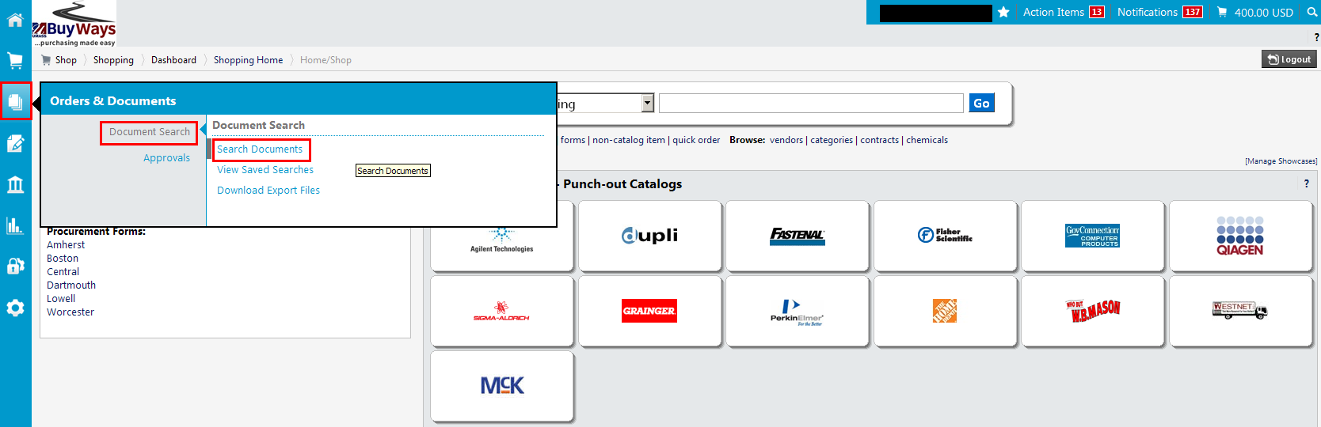

- You can do a ‘simple search’ by entering just your PO Number. Or you can choose the ‘Advanced Search’ option by clicking on the link
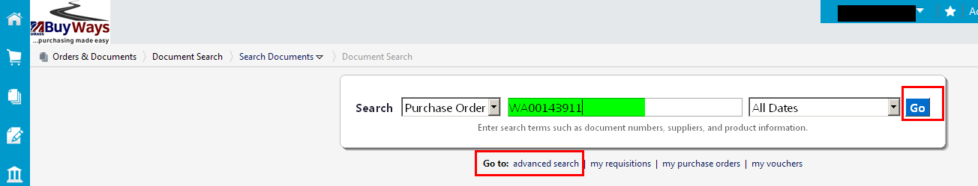
- For an advanced search, enter your search criteria, in this example, we will search for all POs created “Yesterday” by selecting from the date drop down box and clicking “GO”. You can search by many criteria – account number, Project Grant Number, etc.
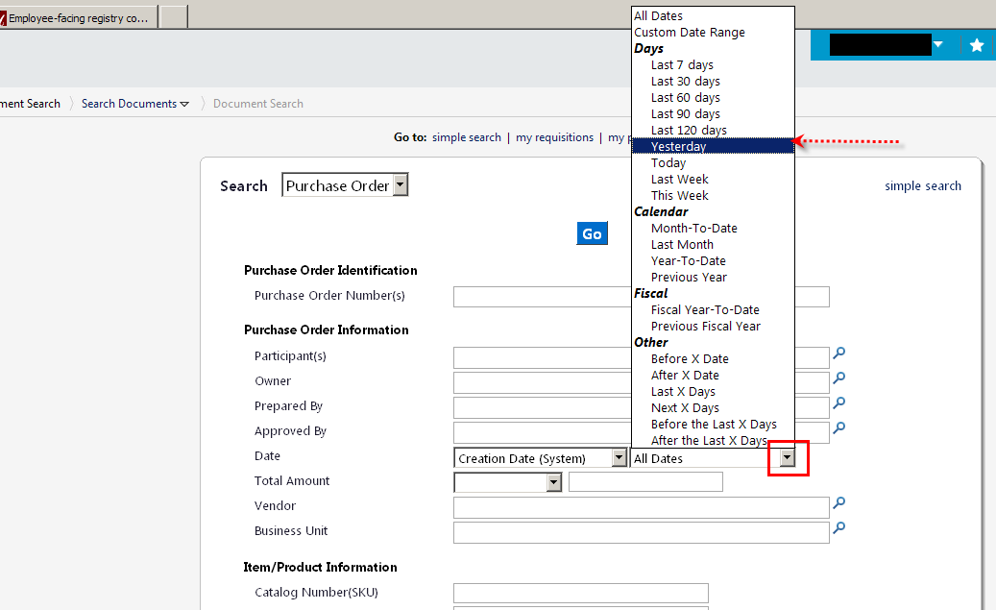

- You will see all POs created in the “Yesterday”… you can select ANY search criteria to refine your search. Click on the PO ID to view your PO. You can also view your requisition from the results screen by clicking on the requisition number.

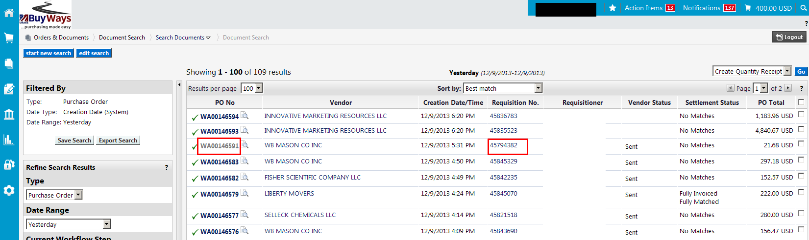

- On the Purchase Order Tab you will see general information regarding your PO.

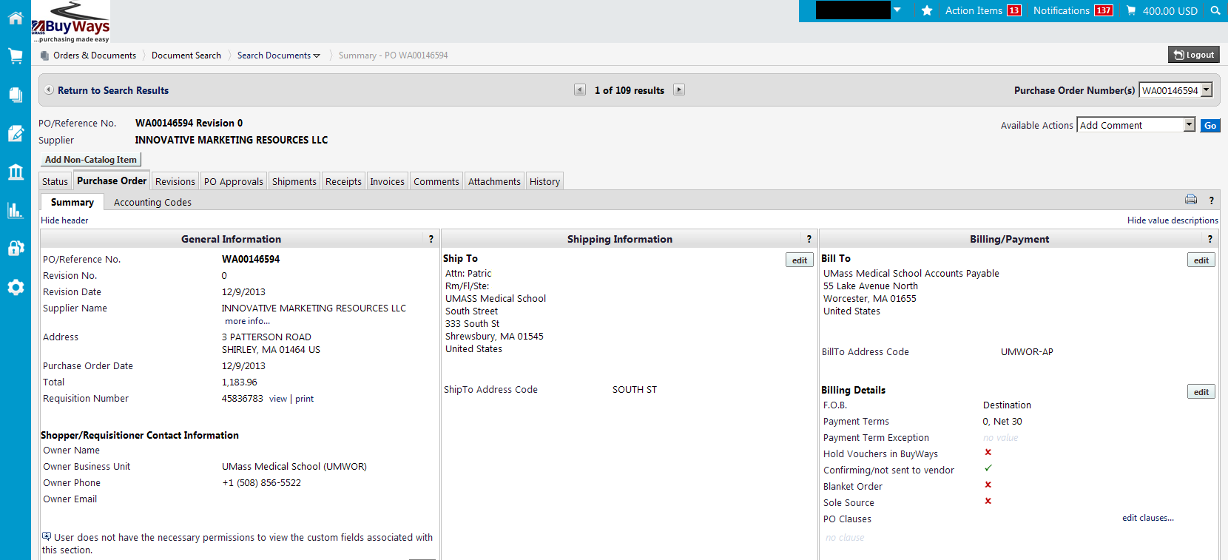

- On the right side of the page you will see that this IS a Confirming Order, (the vendor did not need a hard copy), and it is NOT a Blanket Order PO. Red X = NO, Green check = Yes
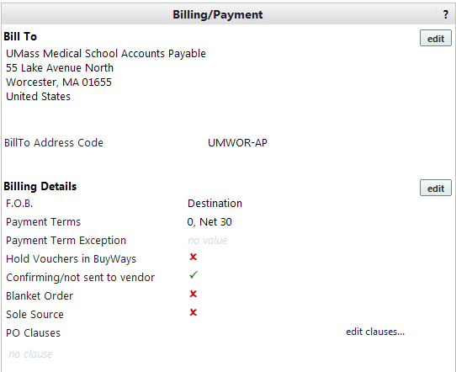

- Scroll down to see the detail of your PO, chart of accounts, requires receiving, items ordered and price.

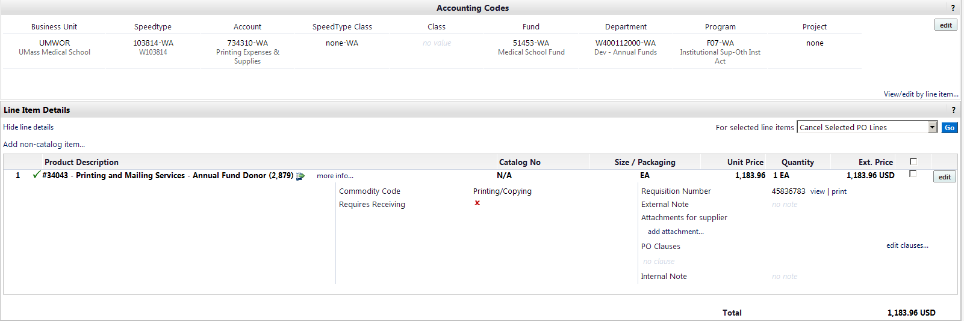
- Click on the Receipt Tab to find information regarding the reciept for this PO… what was received, when, and by whom, etc…

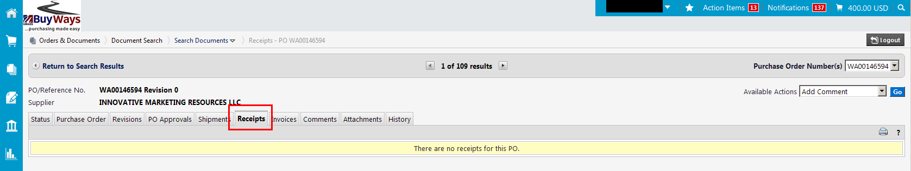

- Click on ANY of the tabs to see more detail about your PO… you can get to the requisition from this page as well, simply by clicking on the Requisition number or “View/Print”.
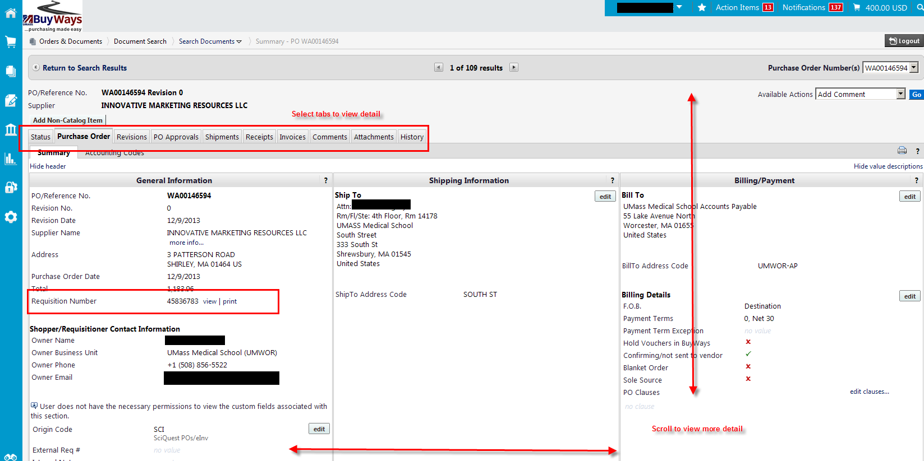

- To print a hard copy of your PO, Choose ‘Print Fax Version’ from the Available Actions drop down box, the click ‘Go’


