Procard Distribution Single Transaction

Log into Peoplesoft Finance Production. From the Navigator, to Purchasing, Procurement Cards, Reconcile, Reconcile Statement.

*Note – if you do not have access to this menu option, please have your Department Security contact send the access request form to worcesterfinancesecurity@umassmed.edu.

**Note – if you do not have access to the cardholder account you need, please send an email to purchasing@umassmed.edu

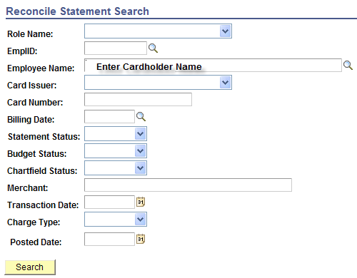

On the Reconcile Statement page, click on the distribution Icon 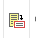 on the transaction to open the enhanced detail information.

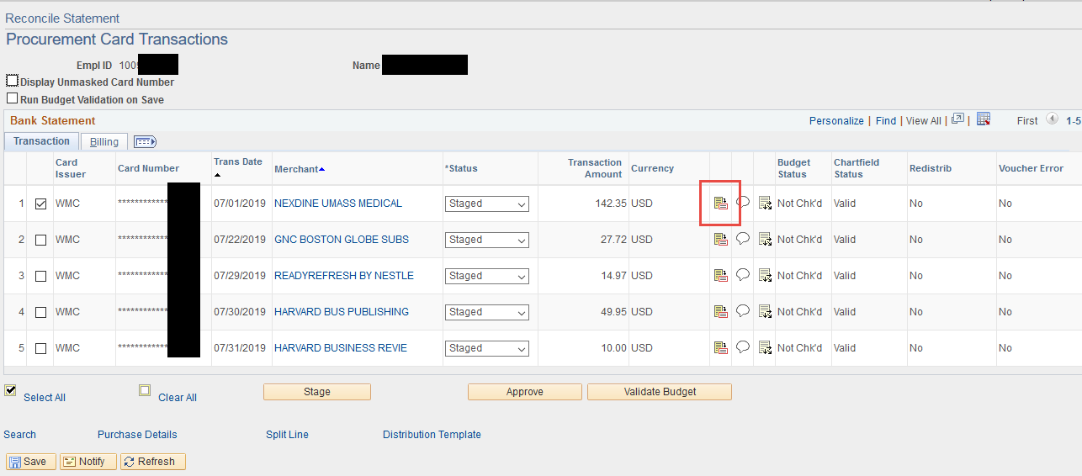

Tab 2 on the Corporate Card Line Item Detail Page will contain any line item description passed by the vendor (not all vendors supply this detail)

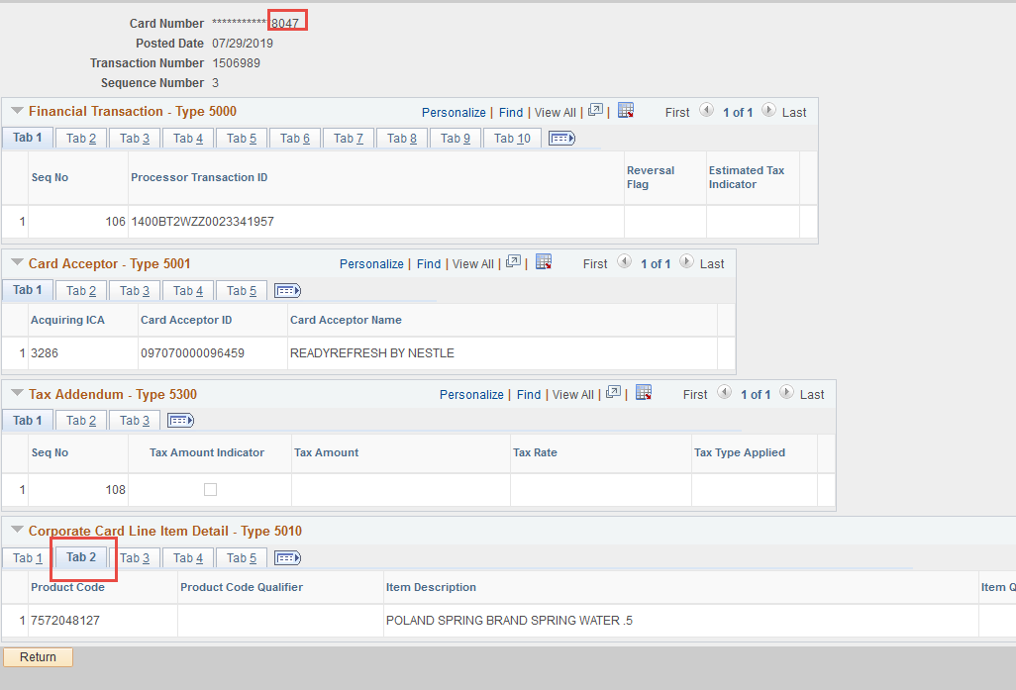

Click on the Cloud icon to add comments or attachments to the transaction

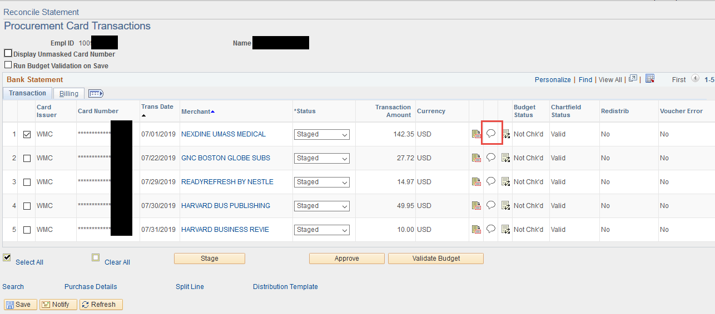

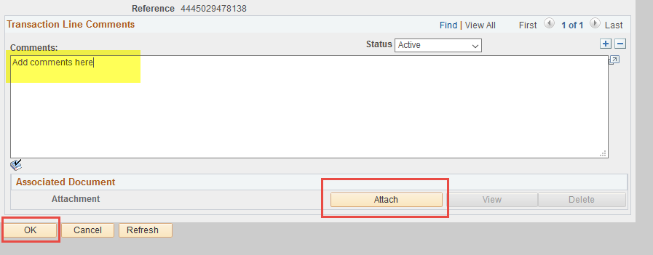

Click on the Distribution Icon to open the reallocation panel

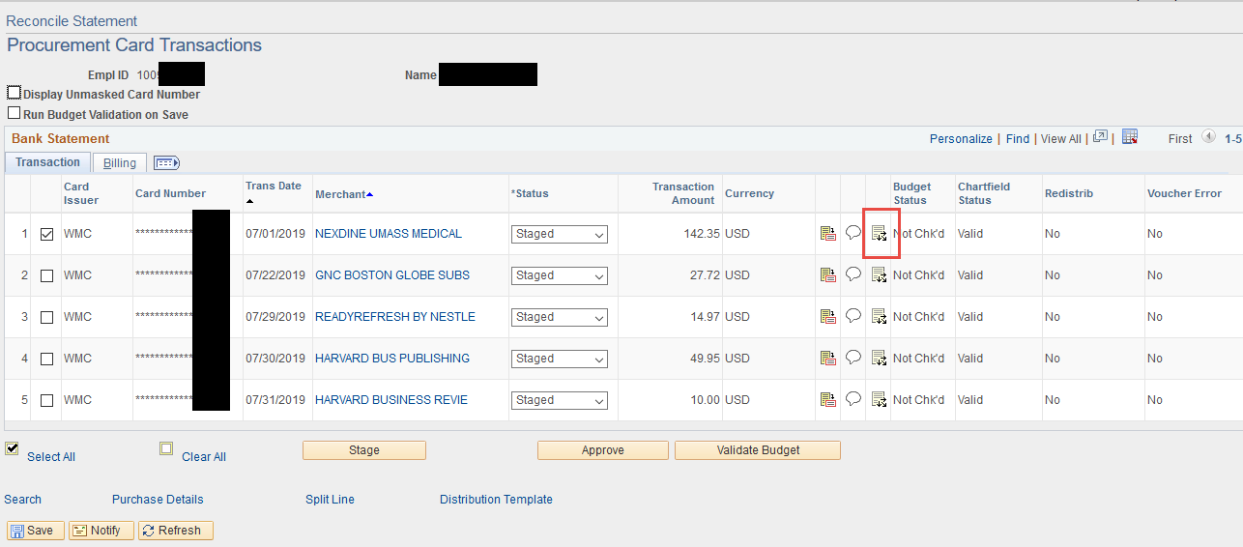

The distribution panel will open showing the default distribution information for the card. Look at the chartfield string values to determine if the chartfield string or account need to be updated. If the information is correct as it is, click OK. If the information needs to be updated, continue to the next step.

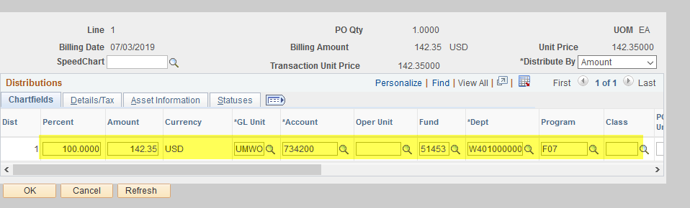

Account number changes:

If the Chartfield string is correct, but the account number needs to be updated, click into the Account Field and delete the current value.

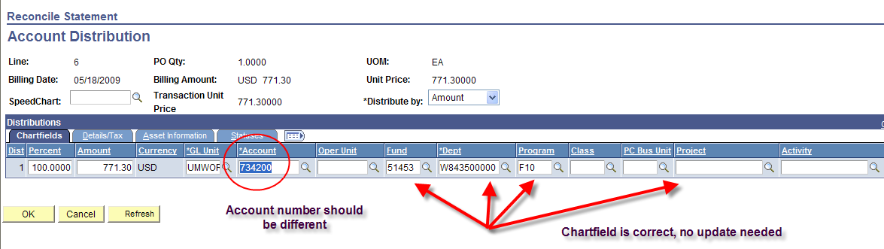

Once you have typed in the new account value, click OK to return to the statement page.

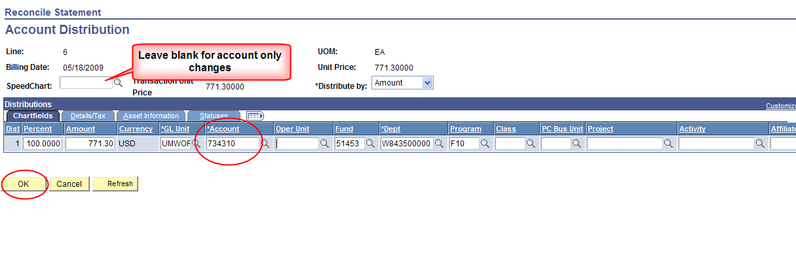
From the statement page, change the Status to “Approved” using the drop down box on the transaction, then save the transaction by clicking the “save” button on the bottom of the screen.

Be sure to wait for the “Saved” message to appear in the upper right corner of your screen before going to your next task. Please note the Redistrib field value has changed to Yes. This is a hyperlink that will take you out to the information about your reallocation (who and when)

when)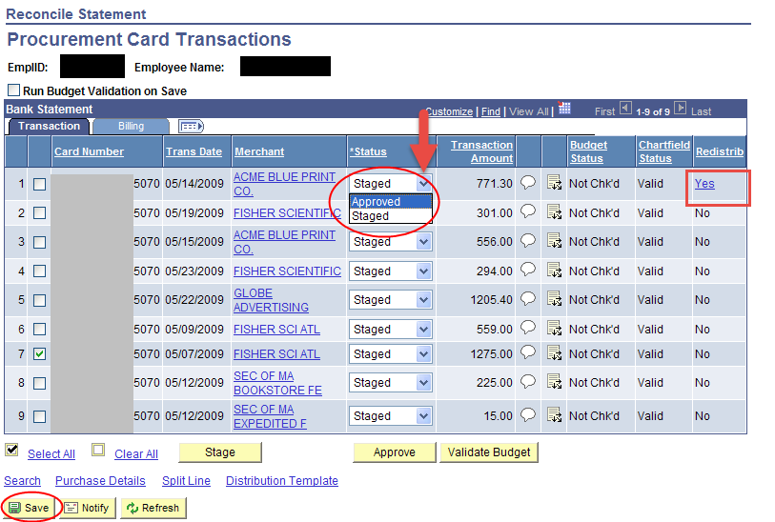

Chartfield number changes:

If the Chartfield string is NOT correct, follow the directions below for changing the value.

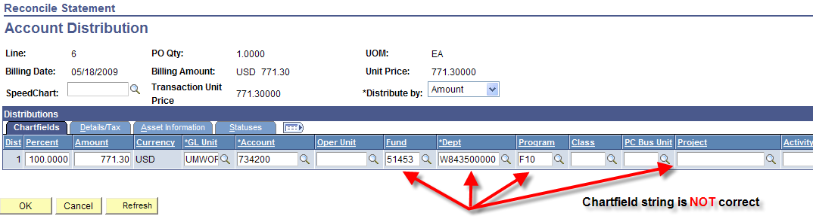

- Click into the SpeedChart field and type the speed type for the correct Chartfield
- Click on the refresh button in the bottom left corner of the screen, then validate the Chartfield information is correct
- Click in the Account field and type the appropriate account code
- Click the OK button in the bottom left corner of the screen

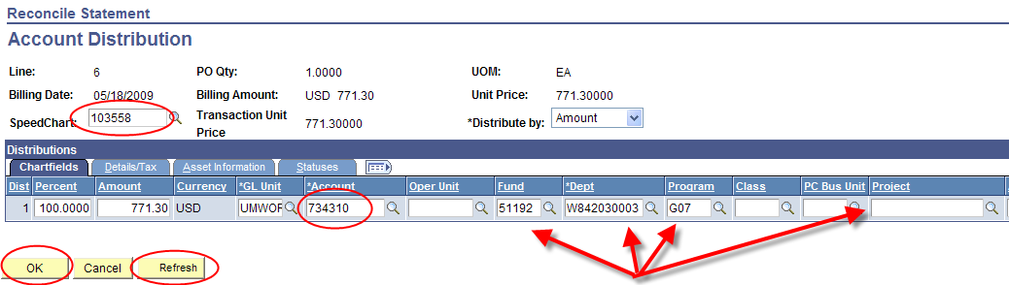

You will be returned to the Reconcile Statement page. Change the status to “Approved” using the drop down box on the field. Next, click the “Save” button on the bottom left.

Please note the Redistrib field value has changed to Yes. This is a hyperlink that will take you out to the information about your reallocation (who and when)

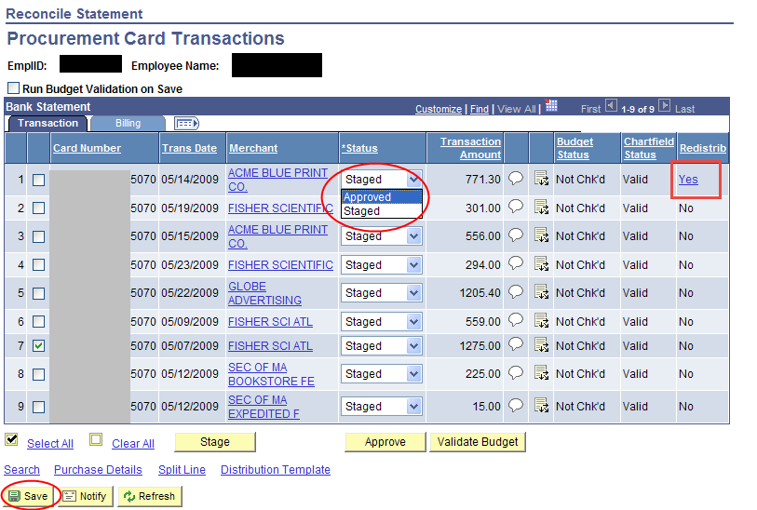

Be sure you see the “Saved” message in the top right corner before proceeding to your next task or logging out.



