Creating a Query in BuyWays

From the left navigation bar, choose the Documents icon (stacked paper), then Document Search, Search Documents
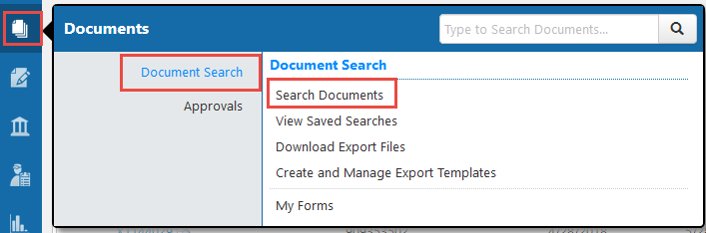

There are 2 types of searches, a simple search will look like the screen shot below, and can be used for a search by a PO number, a vendor name, or the user name. You can also choose the date or date range for your search. Be sure to click ‘Go’ after you enter your criteria information. This search may bring up many more results than you really need. To better refine your search, click on the ‘Advanced Search’ link.
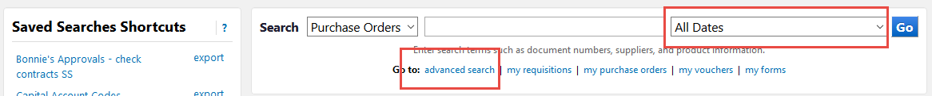

The advanced search allows you to define your query by many fields. The most popular searches are using the chartfield information, which is shown when you scroll down using the right side scroll bar
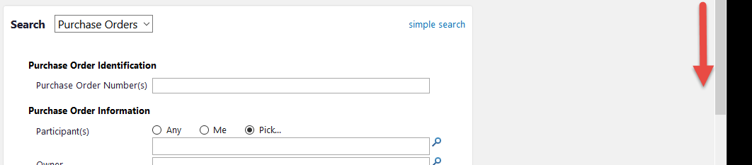

The Custom Fields section allows you to add multiple values to your search criteria. Please note that BuyWays uses a campus suffix at the end of all chartfield values, so it is important to include the ‘-WA’ at the end of each value, or select ‘Starts with’ before you enter a value.
You have the option to add multiple values by clicking the ‘Add another’ link to the right of the field.
Once you have added your value(s), click ‘Search’ at the bottom of the screen.
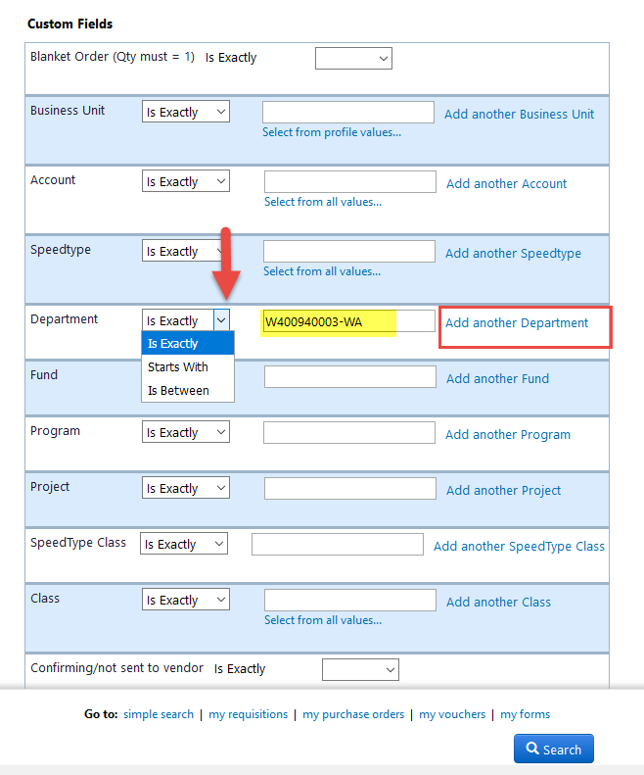

From the search results page, you will be able to further refine your search by using the left side options. For instance, if you click the ‘Open’ link below, your results will be filtered to show only PO’s that are open in BuyWays.
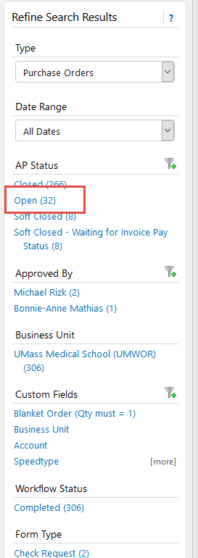

You can also save your search to run in the future. Click the ‘Save New Search’ button
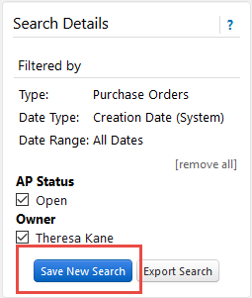
In the dialog box, name your search and choose your Personal folder to store it for later use, then Save.

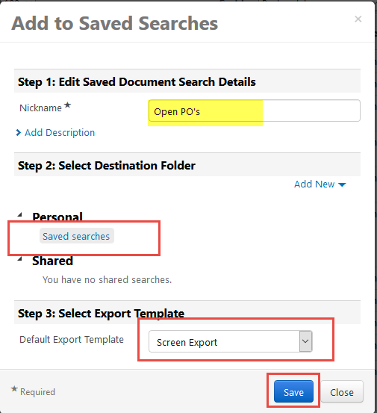
Your search will be available by using the left navigation bar and choosing the Document icon (stacked paper), Document Search, View Saved Searches
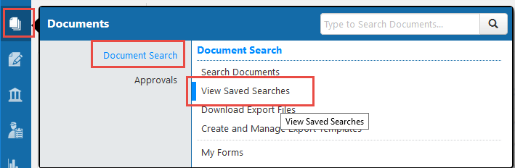

Your search will be available by clicking on the personal folder that you saved it in.
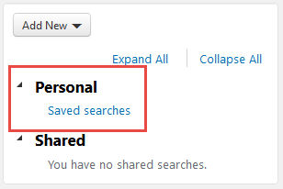

You can run the query by clicking on the name. You can also create a shortcut to the query, which will give you access from the Document Search Page.
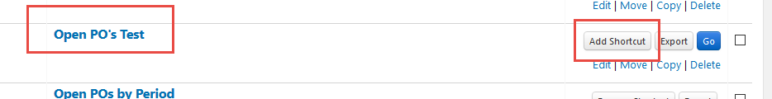

Saved Searches
