How to enroll for a 4th year elective after it is approved on PEP form

This document will walk you through the steps to enroll in your 4th year electives and required Sub-Internships.
Please note that an approved PEP form is a pre-requisite before you proceed with enrolling into the classes, as shown in this document.

Step 1: Login to PeopleSoft Student using the below link

URL: https://sm-prd.wsa.umasscs.net/psp/wsaprd92/EMPLOYEE/SA/c/NUI_FRAMEWORK.PT_LANDINGPAGE.GBL

Step 2: After you land on the below homepage, click on ‘Enrollment’ tile.
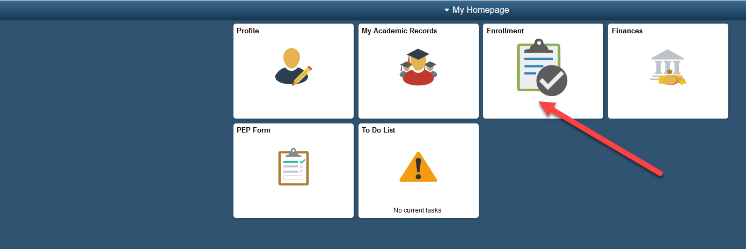

Step 3: On the left of your screen, click on ‘Add a Class’
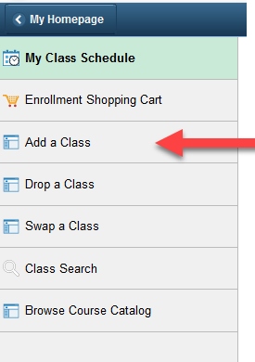

Step 4: You will see a list of terms you are added in. Select a Term for which you want to enroll for a class in and click on ‘Continue’

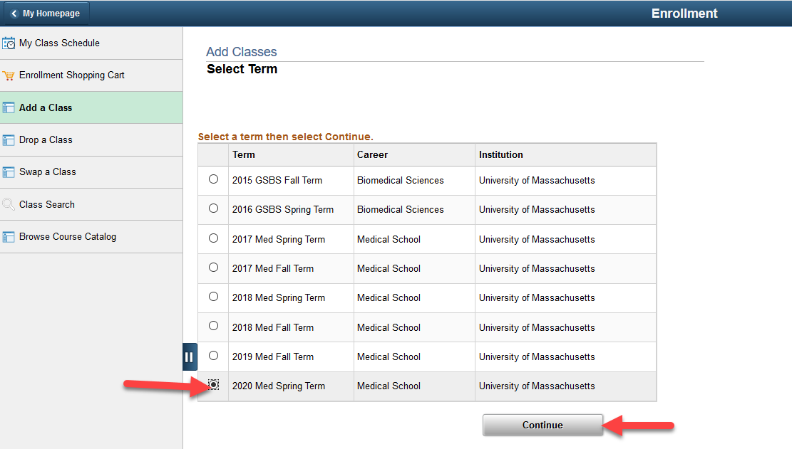

Step 5: On the next screen, click on the ‘Link for Fourth Year Electives’ as shown below.

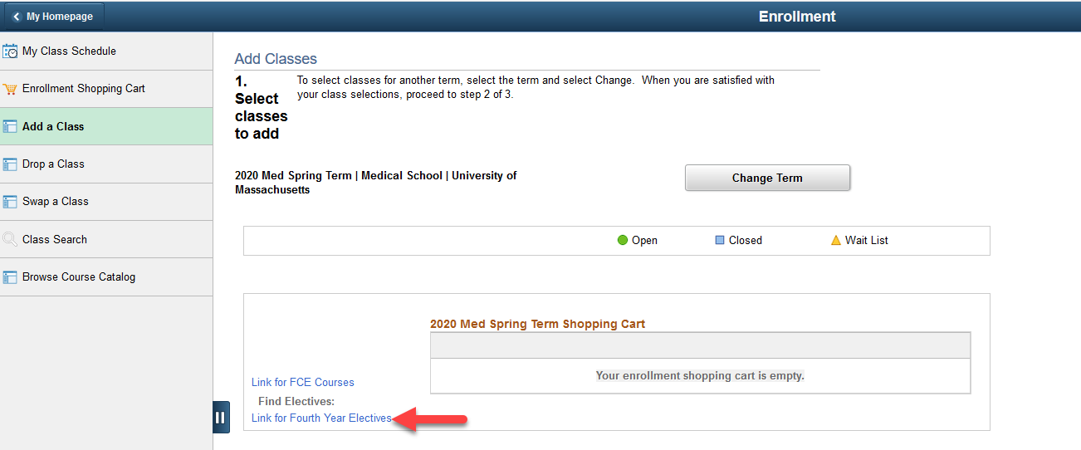

You will get to the below page which lists down all the available sessions for the courses from your approved PEP Form, specific to the term(In this case, 2020 Med Spring Term)

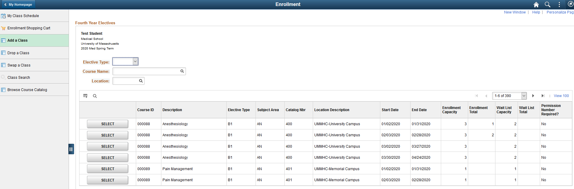

You can see the enrollment capacity(Max slots available) and enrollment total(total slots filled) which will help you identify if there are any slots remaining on the class and select to enroll in it.
If enrollment capacity has been met, you will be put on Waitlist as long as the Wait List Total is not yet met the Wait List Capacity.
Also note that if a class has a ‘Permission Number required’ as Yes, you will need to obtain a permission number from the Faculty or Office of Student Affairs to complete your enrollment.

If you do not see a class from your approved PEP across multiple pages of this screen, please reach out to Office of Student Affairs who will handle such enrollments manually.

As you scroll towards the last few pages of the screen, you will see classes which were ‘Not on your PEP’. To be able to enroll in these classes, you will need to have your PEP form re-submitted and approved by your advisor with these classes added.
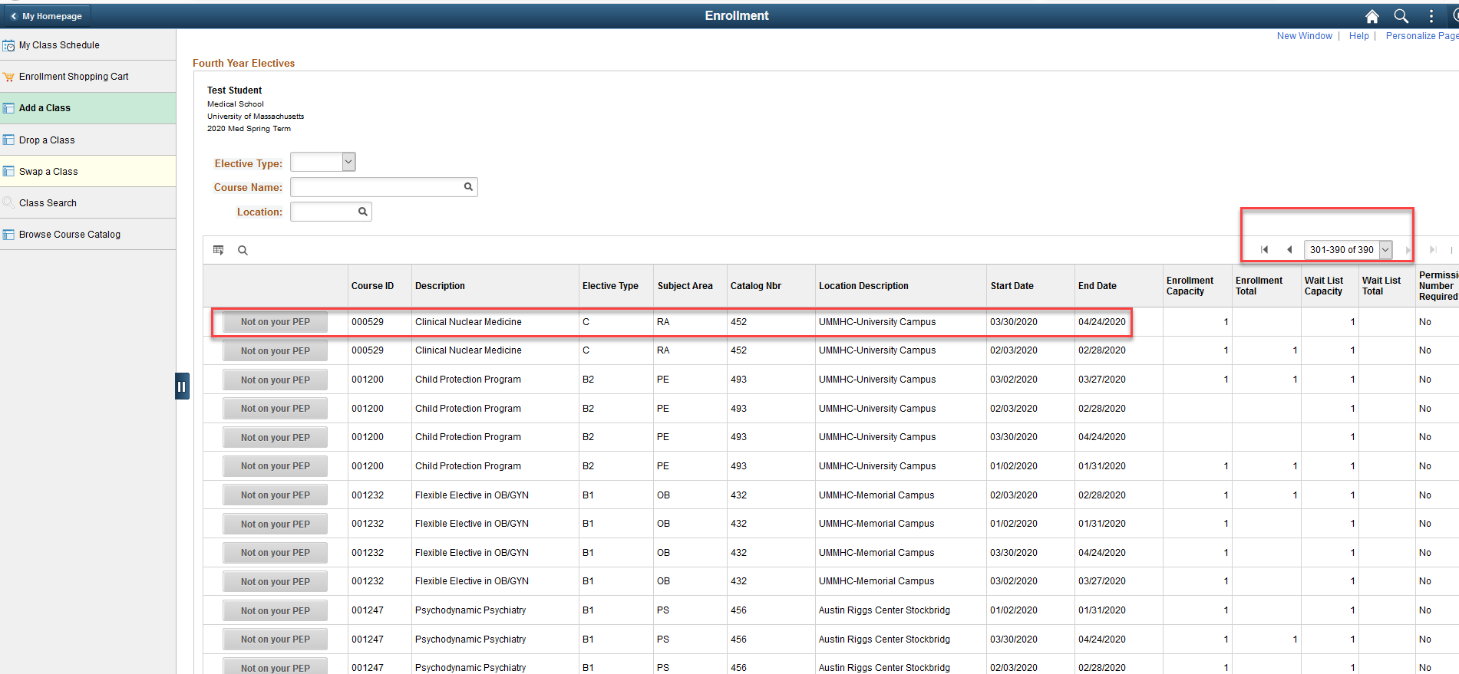
Let’s proceed with enrolling into one of the classes from the initial pages of the screen.

Step 5: On the first page of a screen, select a class you want to enroll into, that has slots remaining, as shown below.
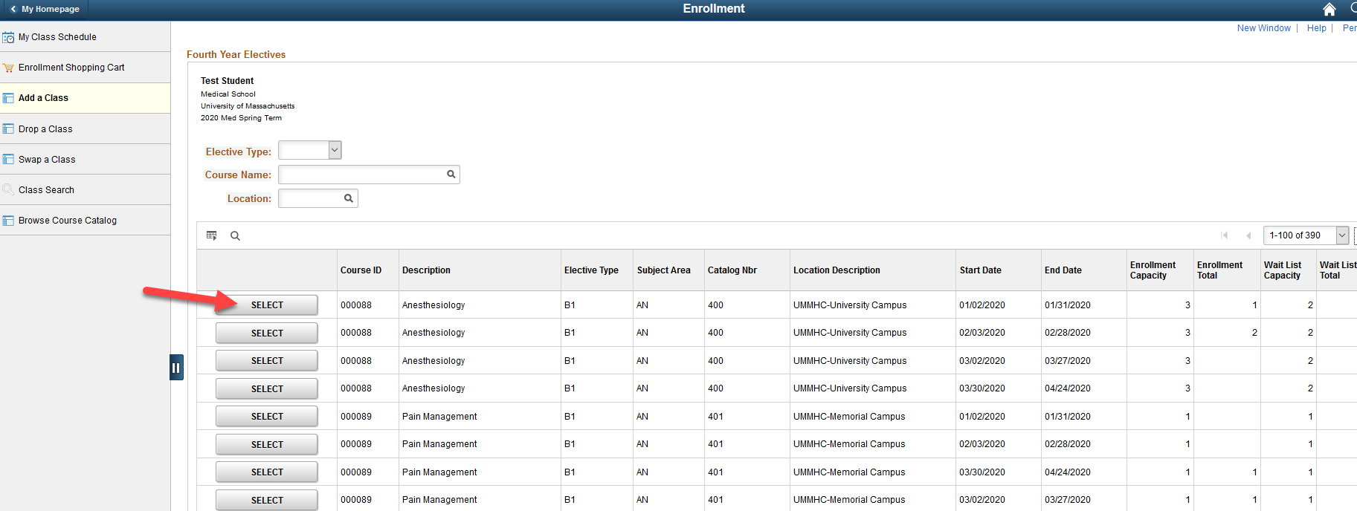

On the next screen, click on ‘Next’
*Please Note that some classes may need you to enter a Permission Nbr. You will need to obtain this number from the course administrator to enroll.

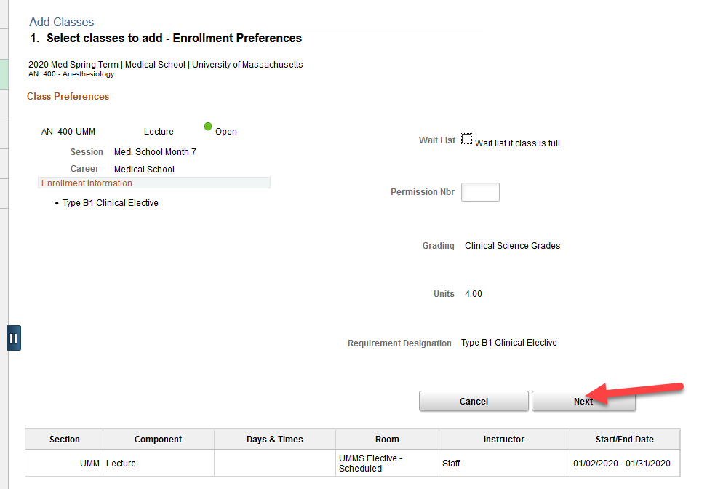

To continue with enrollment, Click on the ‘Proceed to Step 2 of 3’ as shown by Red arrow.
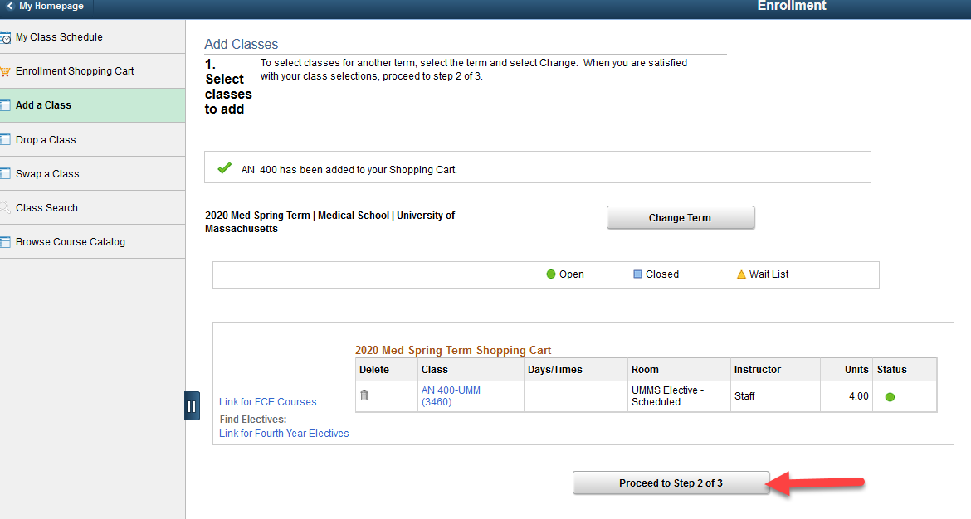

On the next screen, click on ‘Finish Enrolling’.
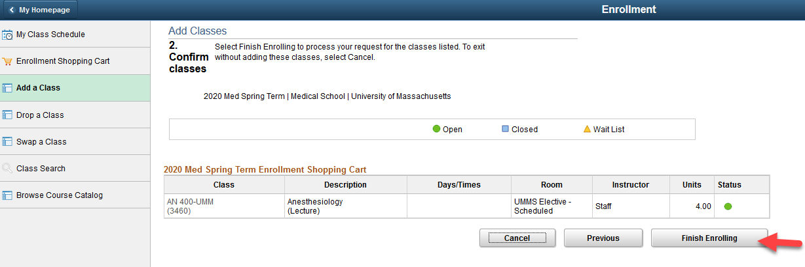

Once the enrollment is successful, you will see a message as below:
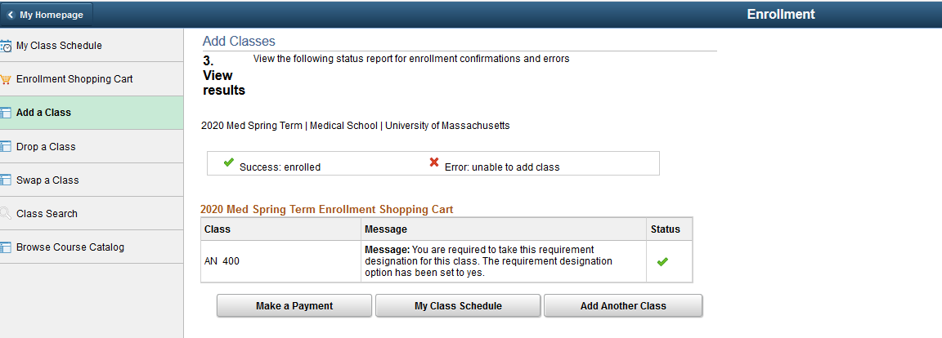
This class will now show as part of the Class Schedule, which can be viewed by clicking the ‘My Class Schedule’ button.
Similarly, you can enroll in more classes by following the same steps after clicking ‘Add Another Class’.
You will be taken to below screen, where you can see the Class Schedule, with newly enrolled class showing up as highlighted.
Since the enrollments are term specific, you can enroll in classes for another term by clicking ‘Change Term’ as shown by the arrow below.
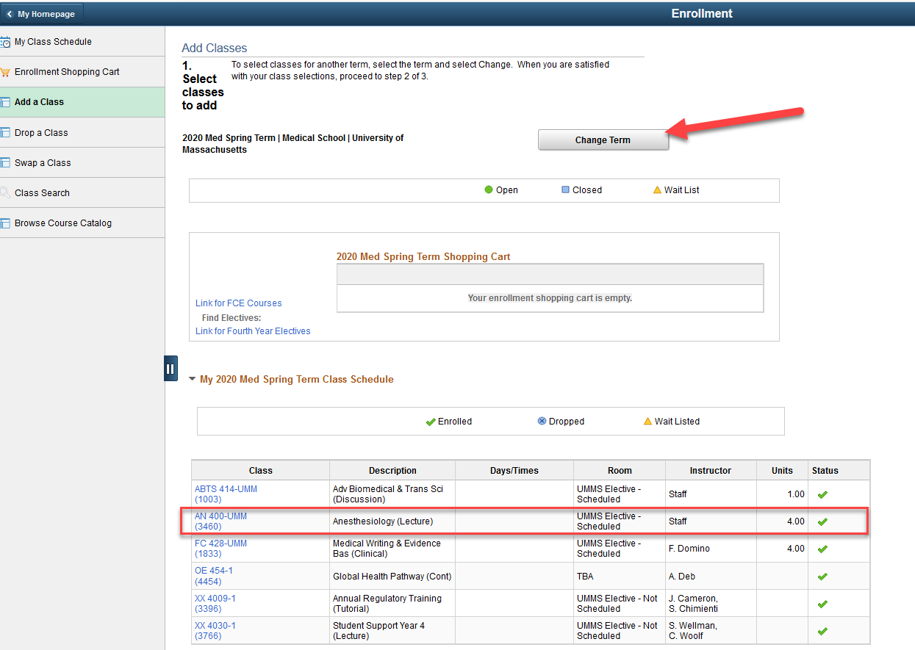
Step 6:Select the term from the below screen and click on ‘Continue’.

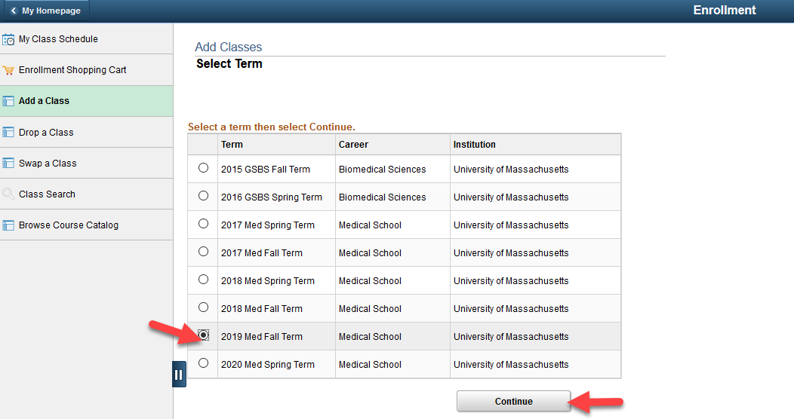

On the next screen, click on the ‘Link for Fourth Year Electives’ as earlier
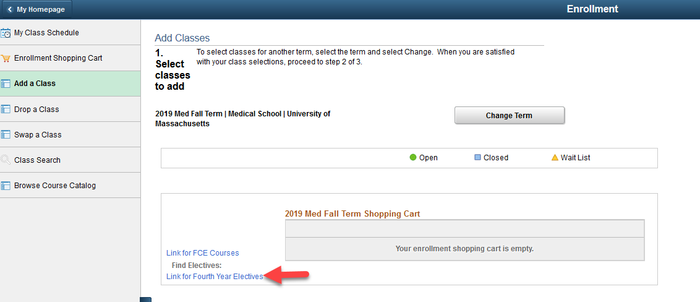
The next steps would be like those followed earlier in this document under Step-05 while enrolling into 2020 Med Spring Term.

