Proposed policies for retest, remediation, and deceleration:

For quick reference, here’s our proposed calendar, assessment week, and assessment model:

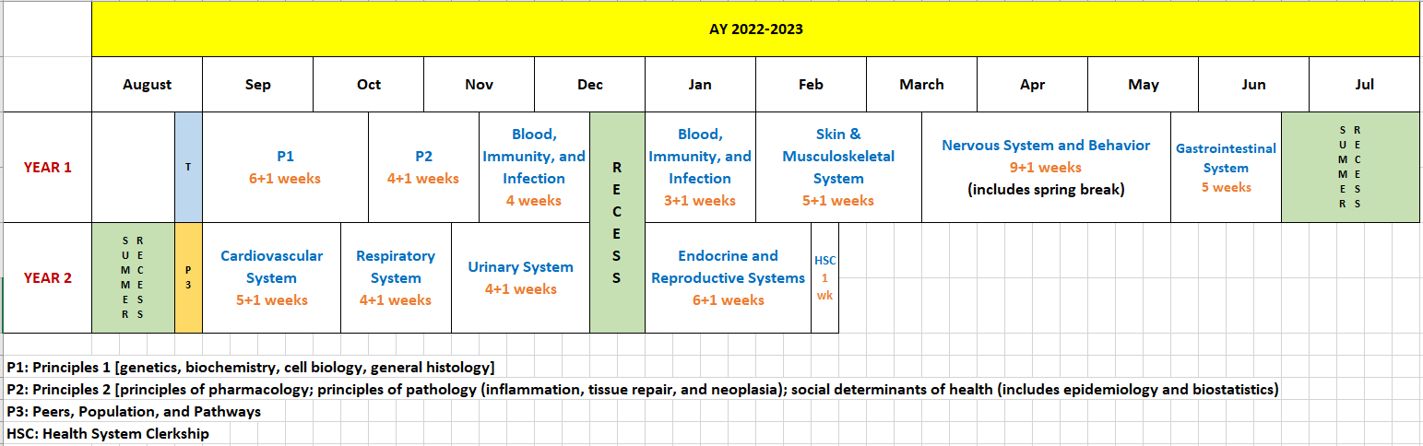

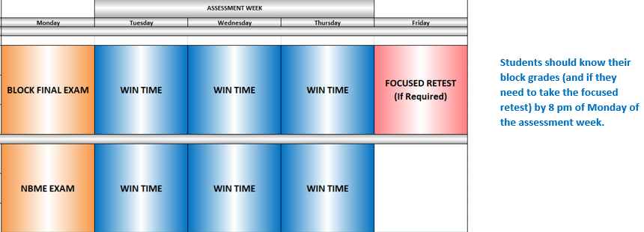

Assessments | When | Type | % Grades
Quizzes | Intra-block | MCQ, FITB, SAQ, Essay | 15-20
Anatomy Lab | Intra-block | Practical | 5-10
Assignments | Intra-block | MCQ, SAQ, Essay | 10-15
Engagement (in required sessions) | Intra-block | Participation | 5-10
Clinical | Intra-block | Competency | 5-15
Others (PBL, TBL, CBL, etc.) | Intra-block | Participation, iRAT, gRAT (tRAT) | 5-10
Block Final Exam | End-block | MCQ, FITB, SAQ | 30-40
NBME Exam | End-block | MCQ | 5*
* considered for being incorporated into longitudinal assessments

Explanation of terms used: -
Block Final Exam – end of block exam designed by block leaders; results available on the same day
NBME Exam – customized shelf exams designed by NBME (national board of medical examiners)
WIN time – what I need time
Focused retest – retesting for eligible students on Friday of the assessment week on failing the block; targeted to the student need
Full retest – retesting over summer (for 1st year blocks) or before entering clerkship (for 2nd year blocks) on failing focused retest for a block, covers entire block content
Remediation – retaking a block next academic year with subsequent class of students
Deceleration Model:
- Fail a block on Monday of the assessment week → focused retest on Friday of the assessment week for eligible students (see below for eligibility criteria)
  - Passing the block final exam is not a requirement to pass the block (refer to table above for percentage block grades), however, block final score should be within 2 SD of mean to pass the block
- Fail focused retest on Friday of the assessment week → full retest over summer (for 1st year blocks) or before entering clerkship (for 2nd year blocks)
  - Fail focused retest exam for a block on Friday → allowed to move forward with new blocks with INCOMPLETE grade until summer (for 1st year blocks) or before entering clerkship (for 2nd year blocks) → full retest of the block over summer (for 1st year blocks) or before entering clerkship (for 2nd year blocks)
- Fail full retest of the block → get an NCR for the block → remediate the following year
  - BSAEB to determine if this is a full-year remediation, or based on the blocks and student record if this can be specific blocks
- On failing focused retest for a second block during one calendar year (i.e. either P1 through GI or CVS through endocrine/reproductive) → stop progress, might audit or utilize professional development option → remediate the following year
  - BSAEB to determine if this is a full-year remediation, or based on the blocks and student record if this can be specific blocks

Note: we discussed several options when remediating the following year:
- retake an entire year after a leave of absence
- retake an entire year after staying enrolled in a professional development course for the remainder of that initial year including relevant CAA experiences
- begin professional development option (5th year) at time of curriculum pause and restart coursework at the time the failed coursework begins in the subsequent year

Proposed Eligibility Criteria for Focused Retest:
- On failing a block on Monday (e.g. ≤75% of block grade), a student will be eligible for focused retest on Friday of the assessment week if their:
  - Block grade is within 2 standard deviations of the mean (SDM), AND
  - Score on the block final exam is within 2 SDM, AND
  - Score on the NBME exam is within 2 SDM
(percent-score is available soon after completion of NBME – can still be graded by 8 pm of Monday of the assessment week)
*Note that the focused retest is individualized to the student’s area(s) of weakness as defined by all assessments in the block.

NBME:
- Would count as 5% of the block grades (scores scaled by SOM)
- Partly cumulative – 5-10% questions would assess content from previous blocks
- Scores on these exams would help early identification of students who struggle with standardized tests; intervention would be planned at strategic points during the curriculum

