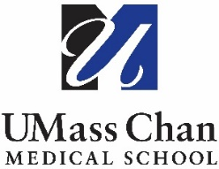
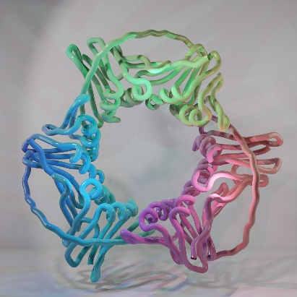

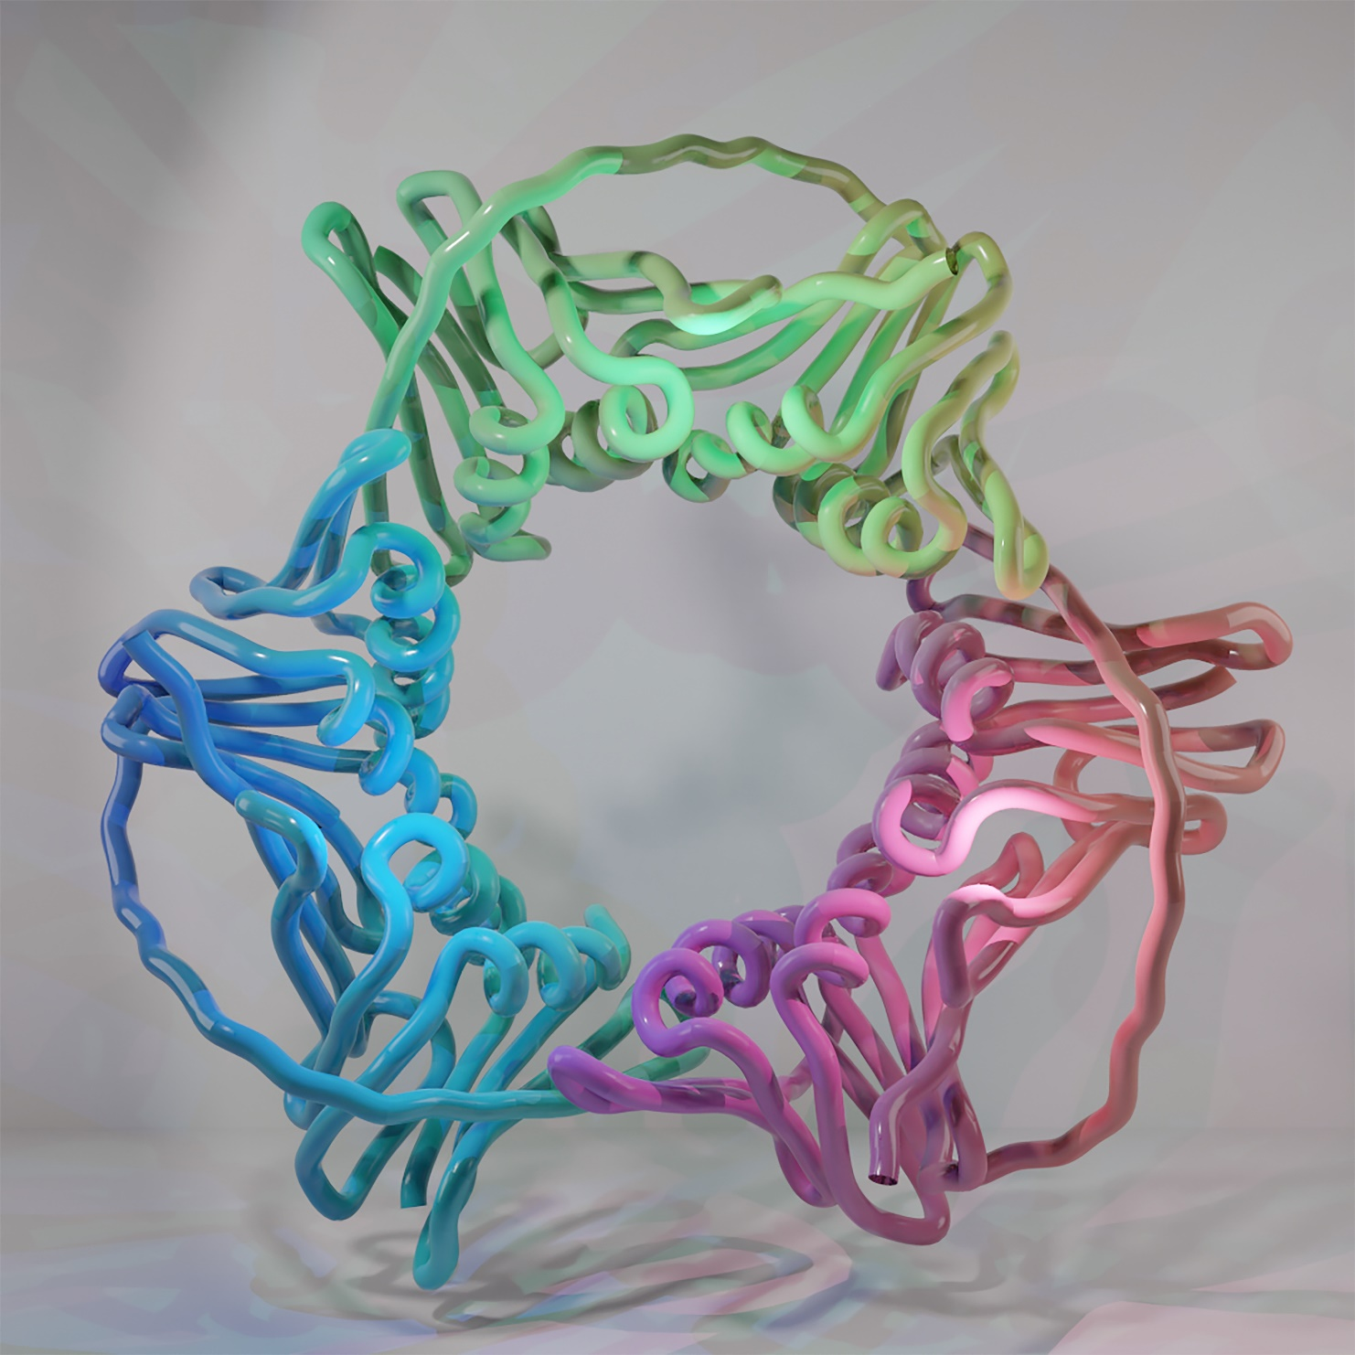

7th Semi-Annual

New England Cryo-EM Symposium

November 16-17, 2021
12:30-5:00 PM | Virtual

Tuesday, November 16, 2021

12:30 pm – 12:40 pm | ~ Welcome and Opening Remarks ~  Nikolaus Grigorieff, UMass Chan Medical School
12:40 pm – 2:30 pm | Session 1  Moderator:  Luke Chao, Harvard Medical School
12:45 pm – 1:05 pm | Sara Kathrin Goetz, European Molecular Biology Laboratory  "Towards high-throughput in-cell cryo-ET: new tools for automated sample preparations and data mining”
1:05 pm – 1:25 pm | Shiwei Zhu, Yale School of Medicine  “Capturing Three-Dimensional Structures of Human Antimicrobial Immune Proteins in Action”
1:25 pm – 1:45 pm | Anthony Schuller, Massachusetts Institute of Technology  "Context matters: The Cellular Environment Shapes the Nuclear Pore Complex Architecture"
1:45 pm – 2:15 pm | Breakout Room: Sessions with Speakers
2:15 pm – 2:30 pm | BREAK
2:30 pm – 3:20 pm | Session 2  Moderator:  Chen Xu, UMass Chan Medical School
2:35 pm – 2:50 pm | Drew Griffin, Gatan  “Maximizing Throughput and Data quality with the BioContinuum HD”
2:50 pm – 3:05 pm | Aubrey Funke, ZEISS Group  “The ZEISS Correlative Cryo Workflow: Your Solution for TEM Lamella Preparation and Volume Imaging”
3:05 pm – 3:20 pm | Breakout Room: Sessions with Sponsors
3:20 pm – 5:00 pm | Session 3  Moderator:  Bronwyn Lucas, UMass Chan Medical School
3:25 pm – 3:45 pm | Judy Huang, UMass Chan Medical School  "Quantitative Structural Analysis of Influenza A Virus by Cryo-Electron Tomography and Convolutional Neural Networks"
3:45 pm – 4:05 pm | Shujun Cai, Yale School of Medicine  “Cryo-electron Tomography of a Parkinson’s Disease-Linked Lipid-Transfer Protein in Situ”
4:05 pm – 4:25 pm | Alex de Marco, Monash University  “Pushing the Efficiency for in Situ CryoEM”
4:25 pm – 4:55 pm | Breakout Room: Sessions with Speakers
4:55 pm – 5:00 pm | ~ Closing Remarks ~
Wednesday, November 17, 2021

12:30 pm – 12:40 pm | Introduction  Brian Kelch, UMass Chan Medical School
12:40 pm – 2:20 pm | Session 4  Moderator:  Chuck Sindelar, Yale School of Medicine
12:40 pm – 1:30 pm | Lightning Talks  Paula Navarro, Harvard  “Cell wall Synthesis and Remodeling Dynamics Determine Bacterial Division site Architecture and cell Shape”  Yangqi Gu, Yale  “Structure of Geobacter Pili Reveals Secretory Rather Than Nanowire Behavior”  Wangbiao Guo, Yale  “In Situ 3D Imaging Combined with FIB-SEM and Cryo-FIB of Subcellular Architecture in Chlorella Pyrenoidosa”  Xingchen Liu, UMass Chan Medical School  “Investigating the Mechanism of Eukaryotic Sliding Clamp Loaders”  Claudio Morales-Perez, Harvard  “Data Analysis to Differentiate Multiple Species in the Sample”  Qiu-Xing Jiang, University of Florida  “Cryo-EM Structure-Based Selection of Computed Poses for Designing High-Potency Chemical Inhibitors of Human PRMT5:MEP50 Complex”
1:30 pm – 2:00 pm | Thunder Discussions
2:00 pm – 2:20 pm | BREAK
2:20 pm – 3:10 pm | Session 5  Moderator:  Chen Xu, UMass Chan Medical School
2:25 pm – 2:40 pm | Natalia de Val, ThermoFisher  “Cryo-EM, a Powerful Tool for Understanding Structure”
2:40 pm – 2:55 pm | Jaap Brink, JEOL  “CRYO ARM Series Electron Cryo-microscopes for Structural Analysis”
2:55 pm – 3:10 pm | Breakout Session with Sponsors
3:10 pm – 4:30 pm | Session 6  Moderator:  Christine Carbone, UMass Chan Medical School
3:15 pm – 3:30 pm | Johannes Elferich, UMass Chan Medical School  “High-Throughput In-Situ Cryo-EM of Hematopoietic Differentiation”
3:30 pm – 3:45 pm | Simon Jenni, Harvard Medical School  “Reconstruction of the Vesicular Stomatitis Bullet-Shaped Virus”
3:45 pm – 4:00 pm | Elizabeth Villa, University of California, San Diego  “Opening Windows into the Cell: Bringing Structure into Cell Biology using Cryo-Electron Tomography”
4:00 pm – 4:30 pm | Breakout Sessions with Speakers
4:30 pm – 5:00 pm | ~ Closing Remarks ~

Thank you to our Sponsors!

