Instructions for Faculty to access class roster

- If Faculty have UMMS account, they can login through SSO Using their NT account and password or they have to login through backoffice link using peoplesoft User id and password.
Faculty who don’t have UMMS Account – Login through back office
Faculty who have UMMS Account – Login through SSO

https://www.umassmed.edu/studentlife/ >> Click on Peoplesoft Icon and give NT account and password
https://wsa-prd.erp.umasscs.net/psc/wsaprd92/EMPLOYEE/SA/c/NUI_FRAMEWORK.PT_LANDINGPAGE.GBL?& >> Give PSCS User id and password

- After login you will be landing on this page
Click on Faculty Center tile

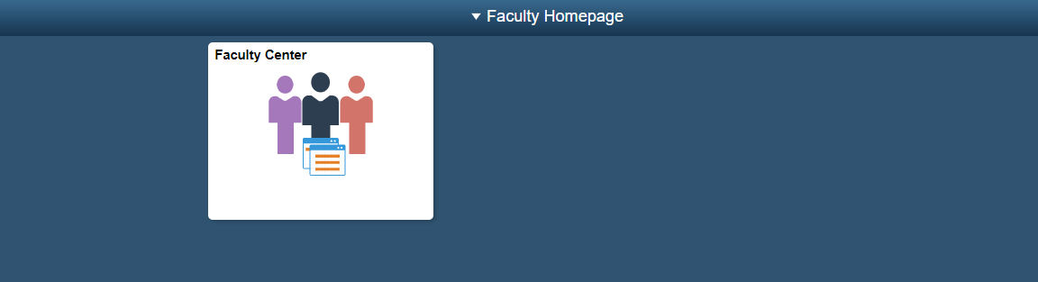

- You will be landing on Faculty Home Page>> My Schedule
You can the change the terms by clicking ‘Change Term’ Button

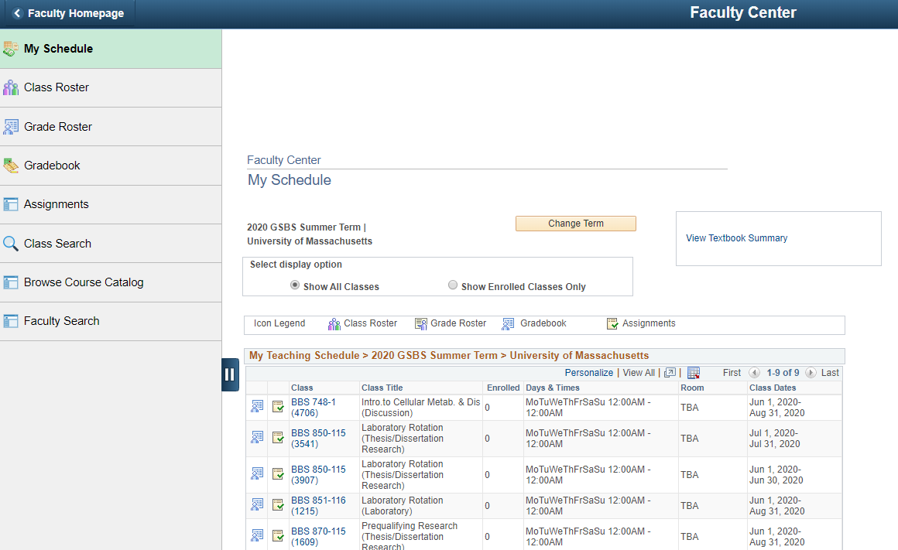

- Click Class Roster, that will show them the classes they are assigned to.

