Expense Report Entry-Job Aid
Contents
Creating an Expense Report (ER) 1
Select employee for whom ER is being entered 1
Enter Header Information 4
Enter Expense Line information 5
Default Accounting 8
Accounting Information for Specific Line(s) 9
Entering Notes 9
Save Expense Report for Later 11
Submitting an Expense Report for Approval 12
Print Expense Report 13
Withdrawing an Expense Report 14
Other options available under the Expense Report menu 14

Creating an Expense Report (ER)

Select employee for whom ER is being entered
- Once you are logged in to the Finance application, click on the Employee Self Service tile which is located on the Financial page.
NOTE: The tiles available to you depend on your security.
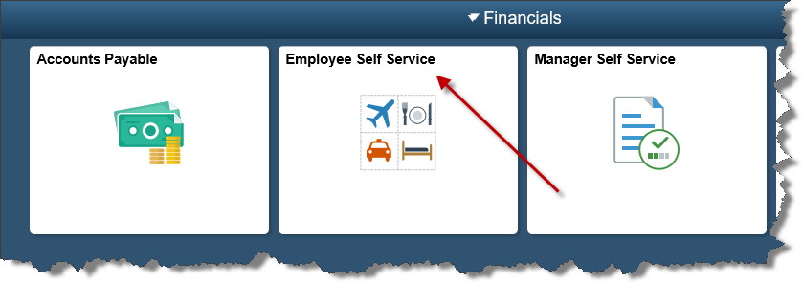

- Under Expense Reports, select Create/Modify.
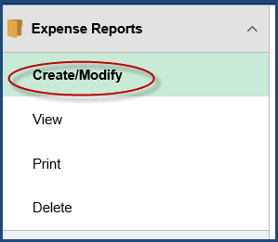

Hint: To hide the navigation on the left side of the page, click the double bars on the edge of the menu.
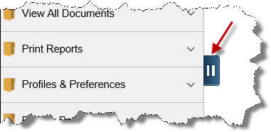

- If you are entering an expense report for yourself, your Employee ID will automatically default in the Empl ID field. Simply click Add.
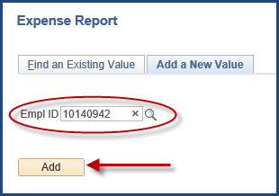

- If you are entering an expense report for another employee:
  - Click on the (magnifying glass) to see a list of employees for whom you are authorized.
  - Click on the desired Employee ID.
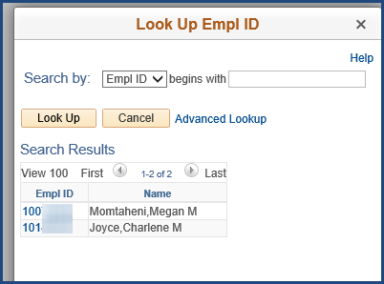
  - Click Add.
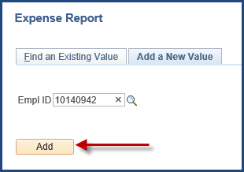

Enter Header Information
- On the Create Expense Report page, complete the following (*required):
  - *Business Purpose – Choose the reason for this travel from the drop-down list. NOTE: If ‘Other’ is chosen, you need to enter the description of the purpose of travel on the Notes section. (See step # 9)
  - *Report Description - Enter the description of the purpose of travel.
  - Terra Dotta ID – Enter the 5-digit itinerary ID from Terra Dotta. (Note: If you have more than one itinerary ID, please add those in the notes section of the expense module.)
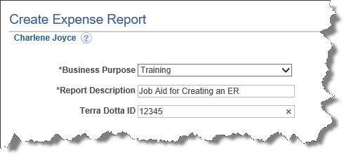
NOTE: You cannot enter default accounting information until at least one detail line has been entered.

Enter Expense Line information
- Enter the expense lines as follows (*required fields):
  - *Expense Date - date of expense/travel date.
  - *Expense Type – Choose appropriate expense type from drop-down list.
    - The expense type Taxable Reimbursement should be selected if an expense is being reported 120 days or more past the date of the expense. It is considered taxable income per IRS regulations.
    - The expense type Business Meeting should be selected if reimbursement is for food purchased for a business meeting. A completed Entertainment Expense Form must be attached to the ER.
  - Description – Enter details related to the expense. NOTE: A full description of the type of expense incurred must be included here for Expense Type ‘Taxable Reimbursement’.
  - *Payment Type - Choose form of payment of ‘Paid via CITI Bank Travel Card’ or ‘Out of Pocket’ from the drop-down.
  - *Amount - Amount of expense. See ‘Additional Entry Notes’ below for information regarding Mileage and Per Diem.
  - *Billing Type - Identify the travel as In-State, Out-of-State or Foreign. Non-Travel should be used for supplies or business meals. 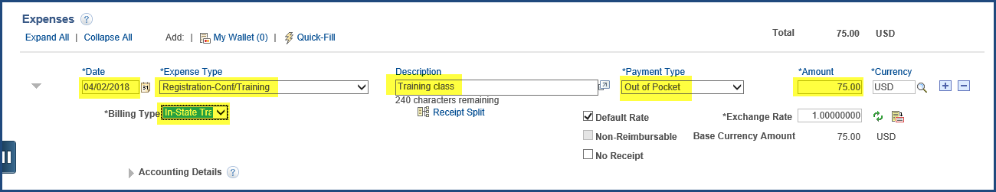
Additional Entry Notes:
- After at least one line has been entered, you can enter information for Default Accounting. (See Step #7)
- To add another line, click the (plus) icon at the end of the detail line.
- To remove a line:
  - Click on the (minus) icon.
  - Click OK when the Delete Confirmation box appears
  - When the Expense Type is ‘Mileage’, the Miles field becomes available.
  - Refer to the Travel Manual for the policy to calculate mileage.
  - Enter the total miles for the travel date.
  - Mileage amount will automatically be calculated when tabbing out of the ‘Miles‘ field.
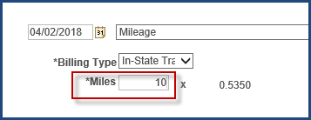

- When the Expense Type is Meals, click the GSA Per Diem Rates link.
You will be taken to the GSA website to access a table of Per Diem rates based on the travel destination. Refer to your campus travel policy documentation for details about Per Diem.
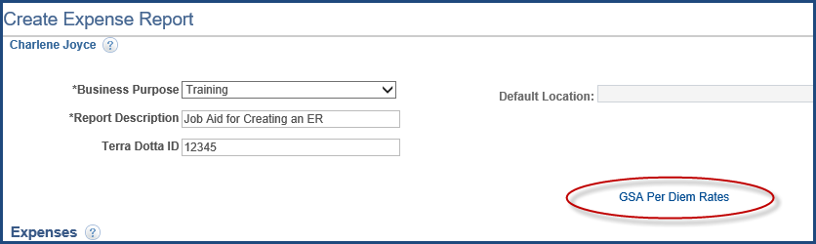

  - When the Expense Type is Business Meeting, all meeting attendees must be identified when reimbursement is for food purchased for a business meeting per IRS regulations. When entering a list of attendees in the module, this list will not appear when you print your report. Please list those attendees in the notes section of the module (see step #9.)
- Click on the Attendees hyperlink, which becomes available when Expense Type is ‘Business Meeting’.
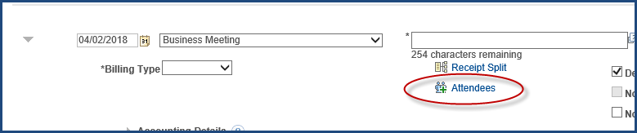

- The Expense Report’s employee’s name will be displayed.
  - Click on the (plus) sign to add the other attendees.
  - Click on the OK button when all names have been added.
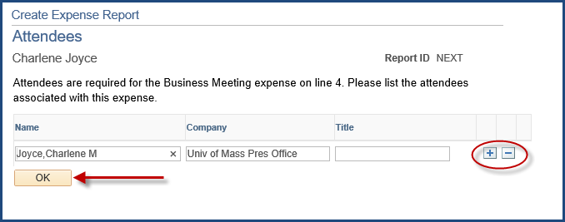

  - No Receipt: The ‘No Receipt ‘ box should not be checked if a receipt is not available.
- Missing Receipt Affidavit must be completed and attached to the
ER for expenses over $25 if required by your campus’s travel policy.
- A notation of the Missing Receipt Affidavit should be added to the Notes for the ER. (See Entering Notes section of this document.)

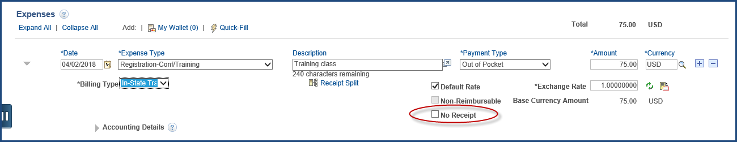

Default Accounting
- Default accounting information will be applied to any Expense Report line where the accounting information was not manually updated. To add default accounting for this Expense Report:
  - Select Default Accounting from the Actions drop-down list in the upper right corner of the page.
  - Click GO.
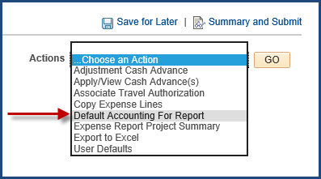

  - Some accounting fields may have default values in them based on your profile.
  - Enter the appropriate value in the ‘Speedchart’ field and press the <Tab> key.
When you tab out of the ‘SpeedChart’ field, the appropriate values for the speedtype will be populated and the SpeedChart value will disappear from the field.
  - Click OK.
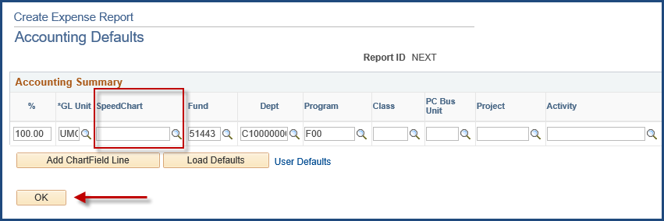

Accounting Information for Specific Line(s)
- To add accounting information for specific expense report lines:
  - Expand the Accounting Details section
  - Enter desired SpeedChart
  - Press <Tab> key
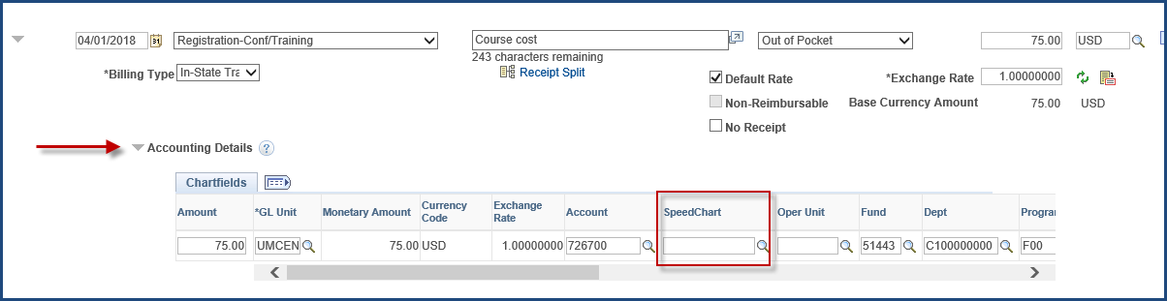

Entering Notes
- To add Notes to your Expense Report, click on Summary and Submit in the upper right corner of the page.
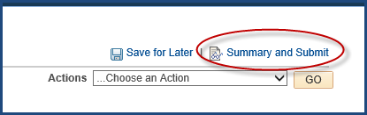

- Click on the Notes hyperlink.
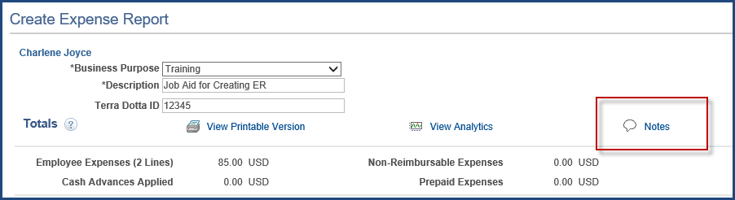

- After adding your comments/notes regarding travel, click the Add Notes button.
NOTE: The first note entered should contain additional information related to the travel that is not included in any of the other description fields.
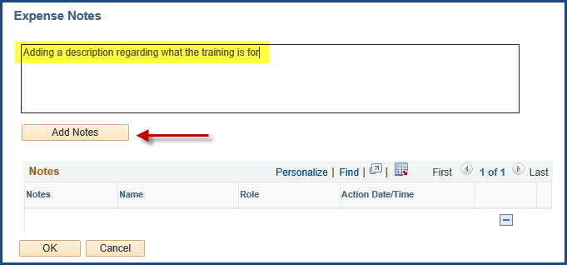

- Notes are displayed in chronological order. Click OK to return to the Summary page.
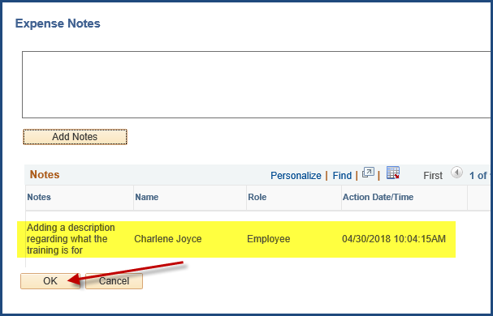

Save Expense Report for Later
- Click Save for Later to save the Expense Report.
  - All data entered into the ER will be saved and an ER number will be assigned.
  - Any errors will be highlighted.
  - The Attachments hyperlink will become available.
  - The ER will not be submitted into workflow.
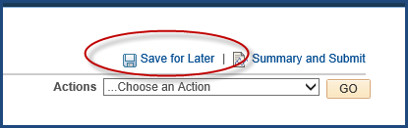

- Any expense lines containing errors will have a (warning flag) upon saving or submitting.
  - To display the error detail, click on the red flag.
  - Any required fields left blank will be highlighted in red.
  - Click Save for Later to ensure that all errors have been corrected.

Submitting an Expense Report for Approval
- When you are ready to submit the Expense Report for approval, click the Summary and Submit in the upper right corner of the page. (If you do not see Summary and Submit, you are already on that page.)

- Select the check box in the certification section of the page and click the Submit Expense Report button.
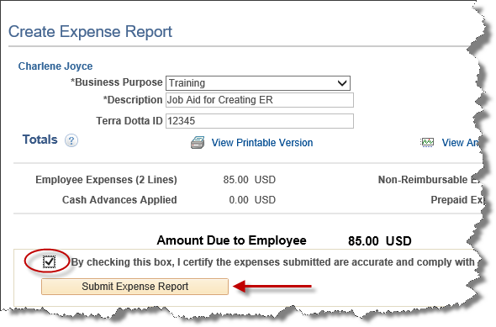

- If there are any remaining errors, you will be taken back to the Expense Details page.
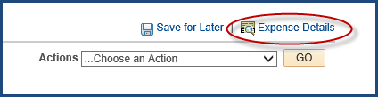
After errors are corrected, go back to Summary and Submit page (Step #15)
- The Save Confirmation page will appear to confirm submission. Click OK.
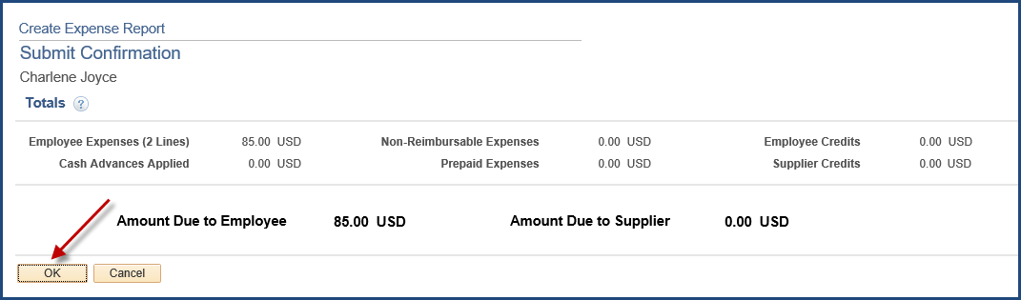

- Make a note of the Expense Report ID that has been submitted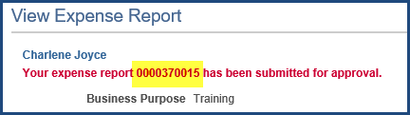

*Note- Once an Expense Report is submitted, it can no longer be accessed by the
employee or authorized user unless it is either Withdrawn or “Sent Back” by an approver.

Print Expense Report
- A printable version of the report can be produced by clicking the View Printable Version hyperlink on the Summary and Submit page.
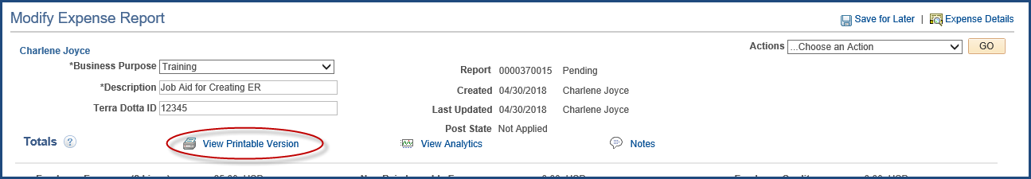

Withdrawing an Expense Report
- If an Expense Report has been submitted but has not been approved, it can be withdrawn from workflow.
  - From the Main Menu, navigate to Employee Self Service tile.
  - Under the ‘Expense Report’ header, click on View.
  - Pull up the ER to be withdrawn.
  - Click the Withdraw Expense Report button.
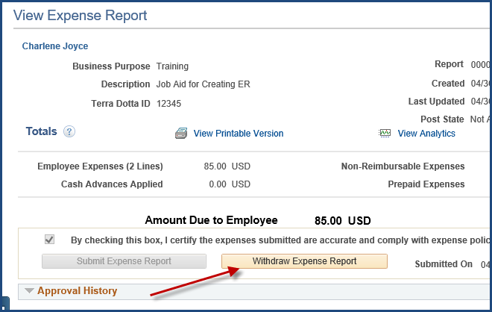

- You will receive a message that the ER has been withdrawn.
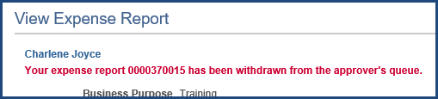

Other options available under the Expense Report menu
- From the Financials page, select the Employee Self Service tile.
- Under the Expense Reports header, click on the desired action.
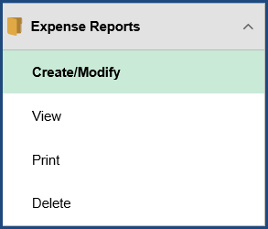

Additional notes regarding actions on an ER:
- An Expense Report cannot be deleted or modified if it has been fully approved.
- An ER can be closed if it has been fully approved, but not published to Payroll.
- If an ER has been submitted but not fully approved, the ER can be Sent Back by an approver for modification or deletion.
- An ER can be viewed and printed at any phase of the approval process including after it has been fully approved.

