Meet the Rural Health Scholars - CLASS OF 2020

Meaghan Foster- SOM (School of Medicine)
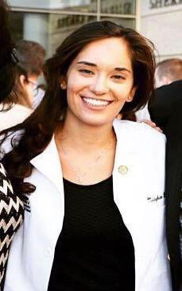
I grew up splitting my time between Groton and Dunstable, Massachusetts. In a small town or rural area, I believe I would have the opportunity to treat children and whole families across critical periods of their development while still potentially getting to know them outside of the medical setting. I also believe a smaller, rural area would facilitate my assimilation into the community and allow me to provide more informed care given my understanding of their environment and community. These characteristics have directed me towards an interest in and desire to learn more about family medicine and primary care.

Hannah Girard, RN- GSN (Graduate School of Nursing)
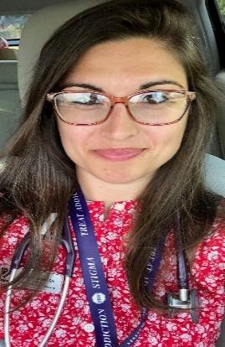
I grew up in the Berkshires directly at the foot of Mt Greylock in the small mill town of Adams. I have also worked in global health in rural settings, such as in relatively remote villages across the country of Rwanda, for example, providing psychosocial public health interventions. I am interested in working as a clinician in a rural area or small town partly because of my own roots growing up in northwestern most Massachusetts, and moreover, because of my professional track record in working alongside various underserved or vulnerable populaces. I hold the belief that when the most vulnerable of our communities is bolstered, the result is that all communities are strengthened. Ultimately, my professional hope is that I will practice in an underserved setting. I aspire to be double-boarded in Family Nursing Practice as well as
Mental/Behavioral Health. I also have strong interests in Wound Care, Tropical Medicine, Palliative/Pain Medicine.
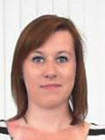

Elizabeth Kern, RN- GSN

I was born and raised in Claremont, NH. I intend to become a travelling practitioner after receiving my certificate in psychiatric mental health and I’d like to focus my efforts in smaller communities at the national or international scale. By virtue of my personal experiences with mental health growing up, I developed a passion and dedication to returning to underserved, rural communities to provide mental health services people may not otherwise receive.

Jesse Loughlin-SOM
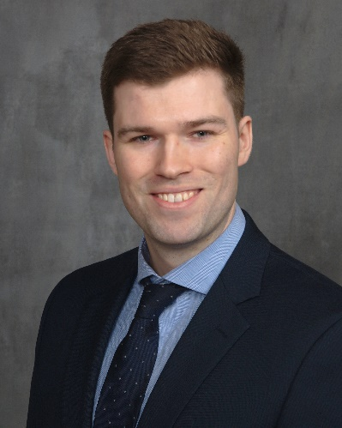
I joined the Rural Health Scholars because I am drawn to working in small towns in beautiful areas. There are unique challenges in rural America, which creates a rewarding work environment. I have had the opportunity to work in critical access hospitals in both Montana and Vermont, which reaffirmed my passion for rural healthcare. I am planning on completing a residency in Emergency Medicine, and hope that after residency I will find myself in a small hospital close to the mountains!

Ashley Millette- SOM

I grew up in Douglas, a town of about 9,000 people in Southern Massachusetts, and have always been drawn to similar places. I think that small towns often nurture an environment of camaraderie and inclusion that is more difficult to maintain in cities and this is something that I’ve greatly missed when living elsewhere. I am drawn to primary care because I hope to play an active role in preventive healthcare. As a part of the primary career community I will have the unique opportunity to both treat my patients for current ailments and help them to maintain their long-term health. Furthermore, being a primary care physician will allow me to form relationships with patients that can lead to better and more efficient care for them.

Timothy Olivier, SOM
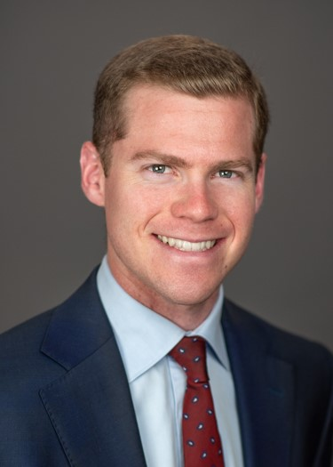
In my first two years at UMass, my longitudinal preceptor was a family medicine physician in Barre MA. My experiences were valuable, and I found that I enjoyed the unique relationship healthcare providers have with their patients in rural communities. I wanted to gain a deeper understanding about practicing in a setting like Barre. This led me to join the Rural Health Scholars. Learning clinical skills relevant to outpatient rural practice, seeing rural hospitals in MA, and learning about issues in rural health care, such as systemic changes to healthcare access, have all given me tools that I will be able to utilize in my future practice.

Heather Patrick, RN- GSN
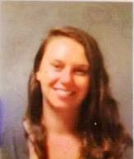
I am a GSN student from Milton, MA in the Family Nurse Practitioner program who is interested in practicing in a community health center in New England. Prior to nursing school I was a case manager at the Boston Health Care for the Homeless Program and am currently a nurse at UMass Memorial Health Alliance-Clinton Hospital. I am a co-leader of the Substance User Disorder student interest group on campus and I started Project Prevail, a mentoring partnership for UMass students with local high schoolers in recovery from substance use disorders.

Victoria Podsiadlo- SOM
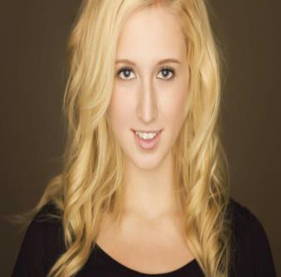
I was born and raised in Chicopee, MA. Working for a small town or even a remote community would make a huge difference in the lives of those who live there, and I think that I would be the happiest/most fulfilled in a place like that. I value being able to build strong, personal relationships with the people of the community that I will be serving.

Cesar Rodriguez, SOM
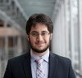
I was born in Colombia and moved to the U.S when I was 7, settling down in Framingham, MA. I went to college in New York where I studied biology and Latin American history before taking a gap year for clinical research and coming to UMass. I’m applying into Internal Medicine with interests in infectious disease and nephrology. I joined rural health because it was, and continues to be, a space that allows discussions of such important topics like social determinants of health, equity, diversity, and the needs of rural communities. With trips to rural hospitals, research in Martha’s Vineyard, and rotations in places like Barre, Ma, rural health has been a fantastic experience during medical school.

