- Visit the IS Self Service web page to submit your Physician/APP Concierge Service request. Select ‘I have a request…’
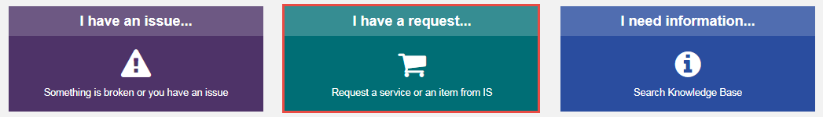

- Under the Training category, select ‘Physician/APP Concierge Services’
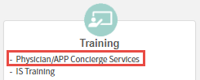

- Ensure the User who is entering information has all up-to-date and accurate information by reviewing the ‘Best Contact Number and Desk Location’ field.
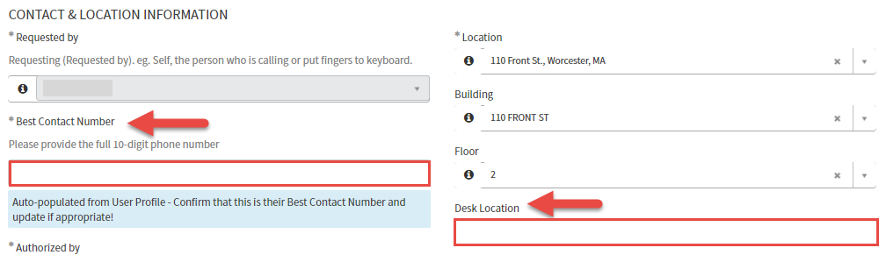

- It’s imperative to list an Alternate Contact familiar with the request for further communication in the event the recipient is not available.
  - This can be an Admin, Front Desk Associate, Nurse Manager etc.
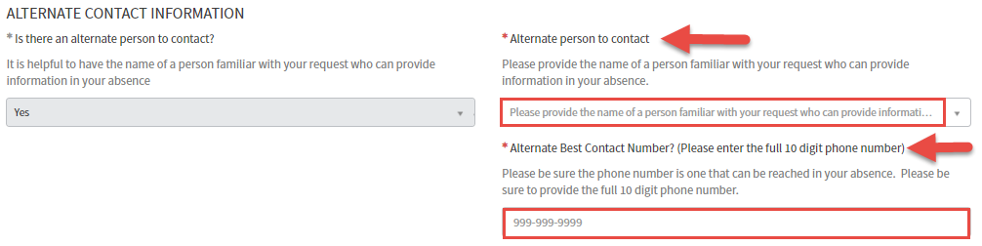
- Be sure to accurately list the Recipient in the event the services are for someone else. This field will auto-populate the User who is creating the request.
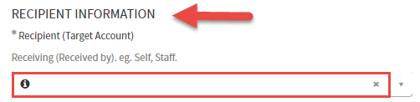

- This section specifies the Provider/APP requesting the services and the specialty they correspond with.
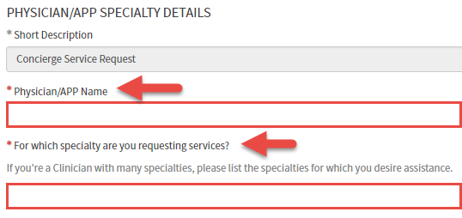

- This field allows the User to free text what they would like to discuss in detail and chose where they would like to conduct these services.
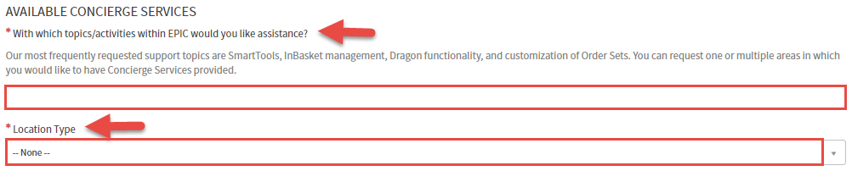
  - If ‘Your office Space’ is chosen, you’re prompted to enter the specifics of your location.
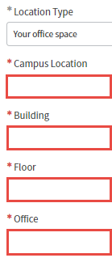
  - If ‘Front Street’ is chosen, we will contact you directly when we’ve organized a qualified classroom.
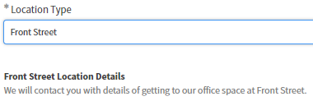

- In this section, we will select the dates/times of availability for these services. Please review the prerequisites in scheduling these services highlighted below.
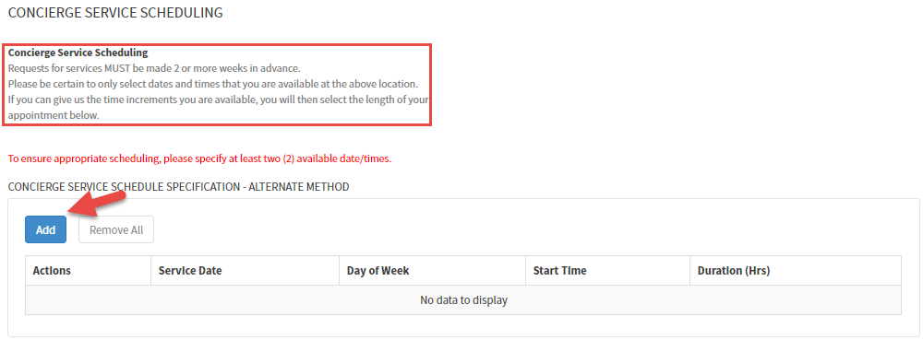
  - To add dates and times, select ‘Add’
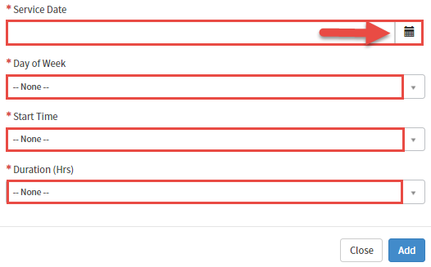
- To enter a Service Date, select the Calendar.
  - *Note: It must be 10 days in advance or it will not accept the date.
- Select a day of the week in the Monday-Friday drop down.
- Choose a Start Time from 0800-1700 in the drop down.
- Choose either 1, 1.5 or 2-hour duration of the service.
  - Please ensure you have offered at a minimum TWO (2) dates of availability.
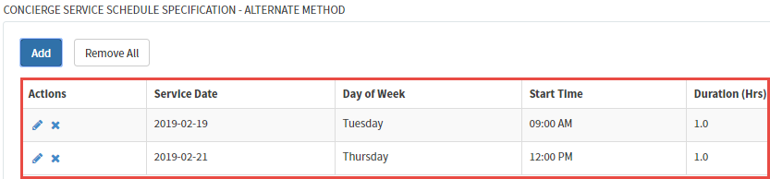

- Please review the expectations of the Epic Personalization Session listed below prior to any upcoming Services.
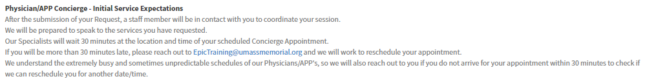

- Once you have completed all Required Information, please Submit the request and the Personalization Coordinator will be in touch with you.

