UMass Medical School Chancellors
by
Ellen S. More, Ph.D
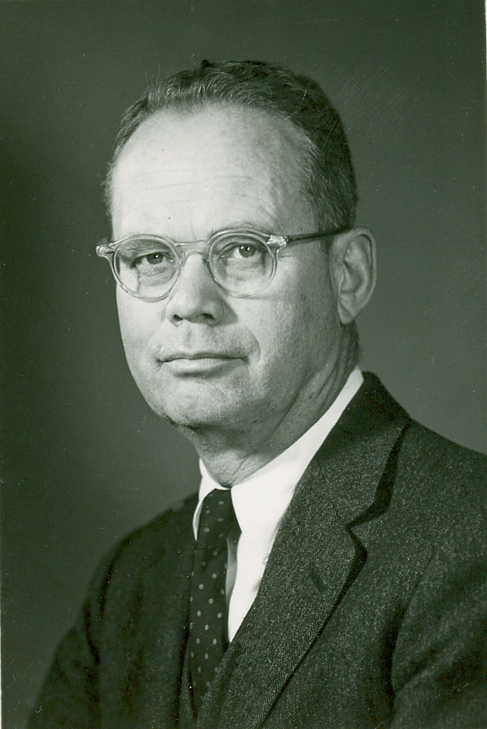
Lamar Soutter, M.D.

Dean, 1964 -1975; Chancellor/Dean, 1974-1975

Chancellor Lamar Soutter, a Harvard-educated thoracic surgeon, hero of the “Battle of the Bulge,” and the founding dean of UMass Medical School, was the principal architect of the University of Massachusetts Medical School, the state’s only public medical school. Over the course of a decade of intense and persistent effort, Dr. Soutter oversaw the lobbying, grant-writing, architectural planning, departmental organization, faculty recruitment, and even the interviewing and selection of the first class of 16 students for the new school. Although he retired in 1975, ten months before the hospital officially opened, he was on hand to greet its first two patients. In the opinion of UMass President John W. Lederle, without Lamar Soutter, “We would not have a medical school in the Commonwealth today...”

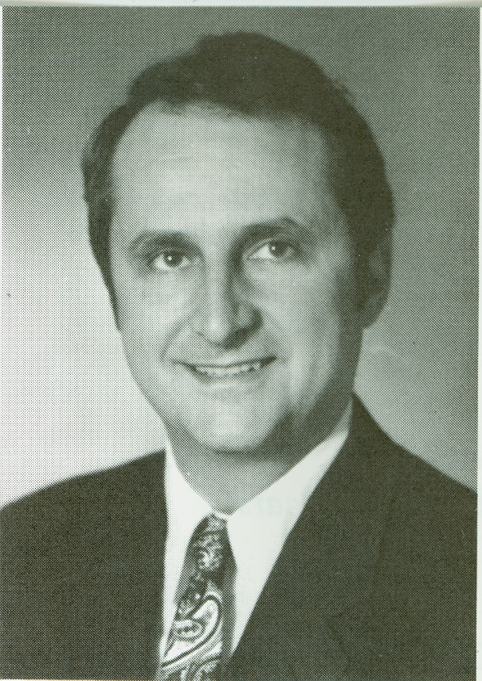
Roger J. Bulger, M.D.

Chancellor/Dean, 1976-1978

Chancellor Roger Bulger, an internist with a keen interest in health policy and previously the first Executive Officer of the Institute of Medicine, oversaw the final agreement with the state to fund completion of University Hospital and the crucial first years of the Hospital’s operation. During his tenure, he pioneered UMass Medical School’s now-deeply ingrained commitment to public service by entering into contracts with the state to provide medical services for the Commonwealth’s residential schools for developmentally impaired children. UMass Memorial Medical Center also won its first Area Health Education Center (AHEC) contract during his tenure, launching a long tradition of support for primary care continuing education, as well as opening the Tri-River Family Health Center in Uxbridge. The Ph.D. in Medical Sciences program, a first step toward opening the Graduate School of Biomedical Sciences in 1986, was initiated during Dr. Bulger’s term as Chancellor.

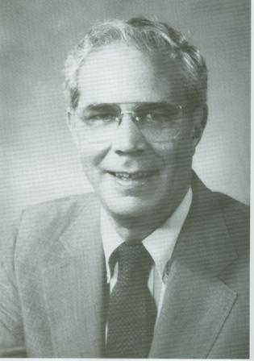
Robert E. Tranquada, M.D.

Chancellor/Dean, 1979-1986

Chancellor Tranquada, an internist with research interests in metabolic diseases and previously Associate Dean for Post-graduate and Regional Medical Education at UCLA, successfully endeavored to advance the research profile of the Medical School. During his years at UMass Memorial Medical Center, the Graduate School of Biomedical Sciences, the Graduate School of Nursing, and the M.D./Ph.D. program were launched, several leading molecular biologists were recruited to campus and, working with Governor Michael Dukakis and the newly formed Worcester Business Development Corporation, construction on Worcester’s Biotechnology Park commenced. New England Life Flight was inaugurated, the only such service in New England at the time, while the University Hospital was designated as the first regional trauma center in New England.

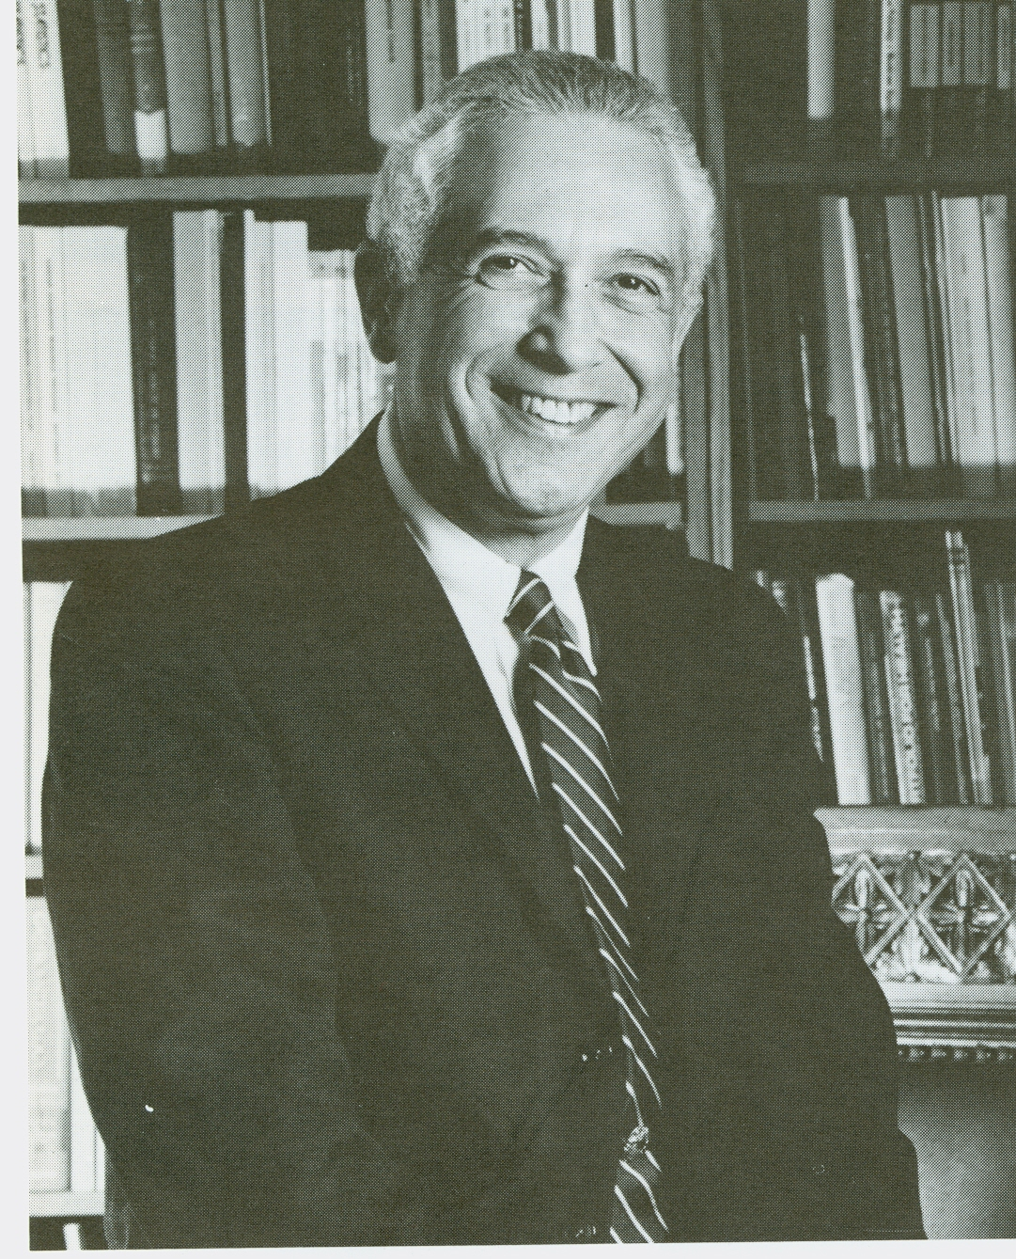
Leonard Laster, M.D.

Chancellor, 1987-1990

Chancellor Laster, a gastroenterologist and previously the President of the Oregon Health Sciences University, made his chief contribution to UMass Medical School through his dedication to the advancement of basic research. Working with the then-chair of the Department of Biochemistry, Michael Czech, to create a distinct Program in Molecular Medicine located in laboratories at Biotechnology Park 2, Dr. Laster’s tenure helped create the infrastructure for the strategic growth of Molecular Biology and Medicine at UMass Medical School, eventually resulting in the School’s rise into the top fifty medical schools in research funding during the administrations of Chancellors Aaron Lazare and Michael F. Collins.

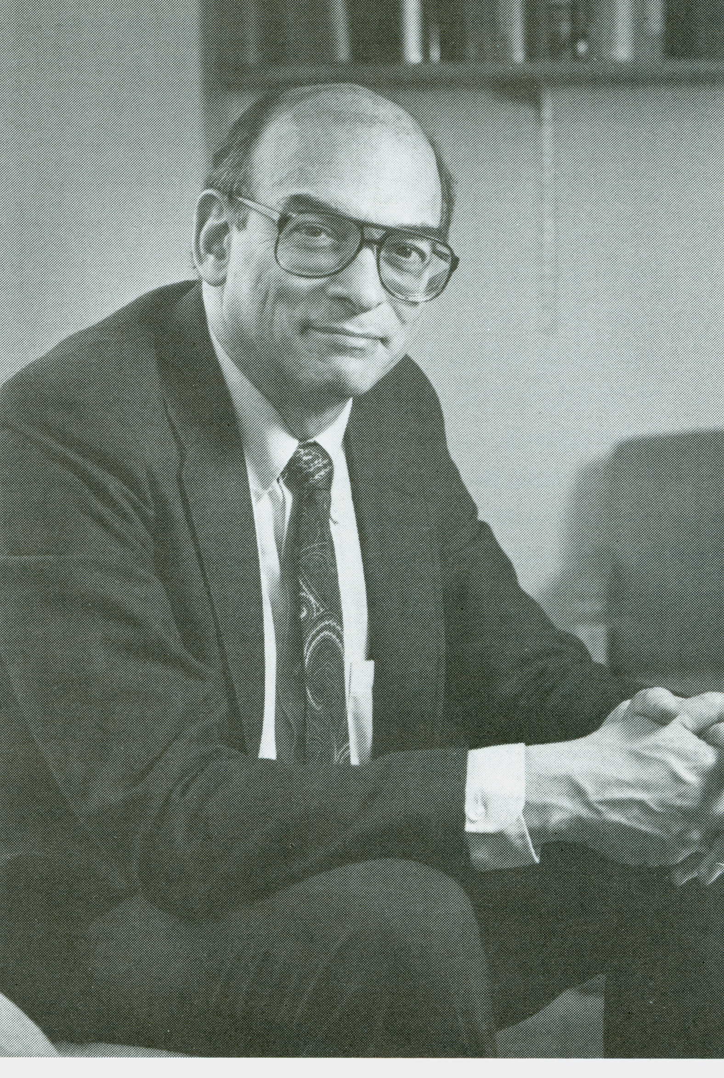
Aaron Lazare, M.D.

Dean, 1990-2007; Chancellor ad interim: 1990; Chancellor: 1991-2007

Chancellor Lazare, a psychiatrist who was previously a Professor of Psychiatry at Massachusetts General Hospital and Harvard Medical School and, from 1982 to 1991, Chair of Psychiatry at UMass Memorial Medical Center, contributed signally to the rejuvenation of primary care medical education while also furthering the School’s commitment to basic research and public sector service. At the same time, he oversaw the privatization of University Hospital and its merger with Memorial Health Care to create UMass Memorial Healthcare, Inc. in 1998. During Dr. Lazare’s chancellorship, the Medical School was awarded a Robert Wood Johnson Foundation Generalist Physician Initiative grant which supported the revamping of the undergraduate medical curriculum to better highlight primary care. It was during this period that UMass Medical School began its long record of ranking in the top ten medical schools in the nation for primary care education. As an outgrowth of the longstanding public sector activity of the Psychiatry Department, the Medical School founded Commonwealth Medicine in 1999 to coordinate expanded public sector services focused on increasing the value of health care expenditures and improving access and care for at-risk and uninsured populations. During Dr. Lazare’s tenure, the Medical School’s research enterprise continued to grow in size, scope and impact. In 1997, UMass Medical School assumed control of MassBiologics, the only university-based, non-profit, FDA-licensed manufacturer of vaccines and other biologics in the nation, from the Department of Public Health. That same year, the Medical School was awarded a $10 million grant from the NIH for the Women’s Health Initiative, with Judith Ockene, Ph.D. as principal investigator. In 2001, the Aaron Lazare Research Building opened. Finally, in 2006 Craig Mello, Ph.D. became the co-recipient of the Nobel Prize in Physiology or Medicine, an award shared with Andrew Fire, Ph.D., for the discovery of RNA interference, or RNAi.

