UMass Memorial Children's Medical Center & the division of Developmental and Behavioral Pediatrics (DBP)
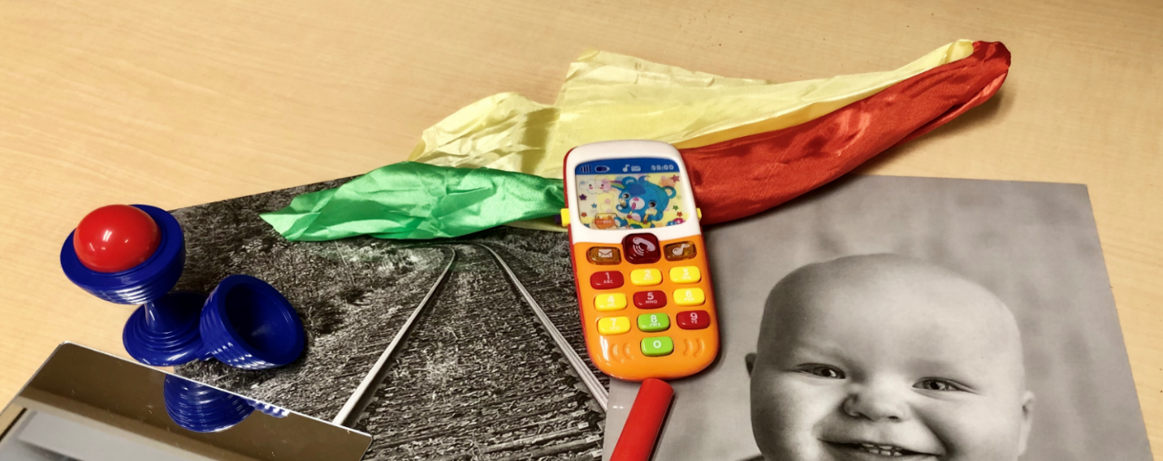
Early Identification of Autism: training on the RITA-T (Rapid Interactive screening Test for Autism in Toddlers) and setting up a two-level autism screening in your practice/program.
Learn about the RITA-T and train to reliably administer and integrate it your practice or program to improve early identification and gain CME/CEU.

Session include:  - Early signs of ASD  - Overview & introduction of the RITA-T  - RITA-T models in Early Intervention and Primary Care  - RITA-T reliability training  - RITA-T kits available for purchase ($60 for the kit + $15 shipping = $75)  - All those who registered will have access to online training, videos, scoring sheets and manual. | Thursday April 9, 2020  ZOOM training  1:00pm - 4:30pm  Two options:  1) Do 90 minutes Zoom overview and then do online training individually  Or  2) Stay for the whole 3.5 hours and do overview and group training

REGISTRATION FEE FOR THE TRAINING: for those seeking CEU and CME:
$15
To pay by Credit Card, register and pay here. There is a small fee to pay by credit card
If you were interested in purchasing the screening kit, we have attached the order form below and we will update you as soon as we are able to ship the kits out. The total cost for the kits are $75 ($60 kit + $15 shipping costs)

https://umassmed.ungerboeck.com/prod/emc00/register.aspx?OrgCode=10&EvtID=5924&AppCode=REG&CC=119122303651

CME Accreditation Statement  The University of Massachusetts Medical School is accredited by the Accreditation Council for Continuing Medical Education to provide continuing medical education for physicians.  Designation Statement  The University of Massachusetts Medical School designates this live activity for a maximum of 3.5 AMA PRA Category 1 Credits™. Physicians should claim only credit commensurate with the extent of their participation in the activity. Nursing: This offering meets the requirements for a maximum of 4.2 contact hours, as specified by the Massachusetts Board of Registration in Nursing (244-CMR 5.04). Each nurse should claim only those hours of credit that he/she actually spent in the educational activity. At this time we are not offering certification for MOC Part 2, ABP. You may contact the ABP directly to inquire approval for MOC certification. | 