UMass Memorial Children's Medical Center & the division of Developmental and Behavioral Pediatrics (DBP)
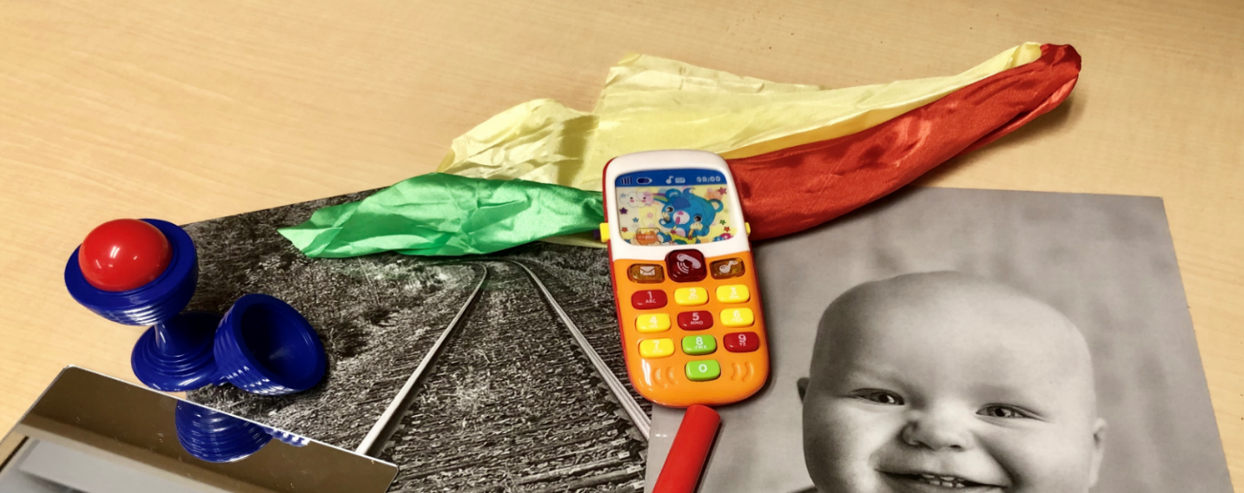
Early Identification of Autism: training on the RITA-T (Rapid Interactive screening Test for Autism in Toddlers) and setting up a two-level autism screening in your practice/program.
Learn about the RITA-T and train to reliably administer and integrate it your practice or program to improve early identification.
Session include:  - Early signs of ASD  - Overview & introduction of the RITA-T  - RITA-T models in Early Intervention and Primary Care  - Ongoing Study for Validation of RITA-T through Telehealth  - CME Credits (see below)  - RITA-T reliability training  - RITA-T kits available for purchase ($60 for the kit + $15 shipping = $75)  - All those who registered will have access to online training, videos, scoring sheets and manual. | Thursday December 10, 2020  Zoom Training  1:00pm - 4:30pm  REGISTRATION FEE FOR THE TRAINING: $75  To pay by Credit Card, register and pay here. There is a small fee to pay by credit card

CME Accreditation Statement
The University of Massachusetts Medical School is accredited by the Accreditation Council for Continuing Medical Education to provide continuing medical education for physicians.
Designation Statement
The University of Massachusetts Medical School designates this live activity for a maximum of 3.5 AMA PRA Category 1 CreditsTM. Physicians should claim only credit commensurate with the extent of their participation in the activity.
Nursing: This offering meets the requirements for a maximum of 4.2 contact hours, as specified by the Massachusetts Board of Registration in Nursing (244-CMR 5.04). Each nurse should claim only those hours of credit that he/she actually spent in the educational activity

