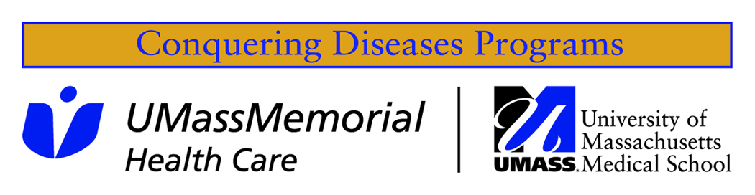

Conquering Diseases  October 2015  Newsletter  Conquering Diseases Program  UMass Medical School  Ambulatory Care Center  55 Lake Ave North  Worcester, MA 01655  508-856-2557  Toll-free 855-937-2067  www.umassmed.edu/  conqueringdiseases  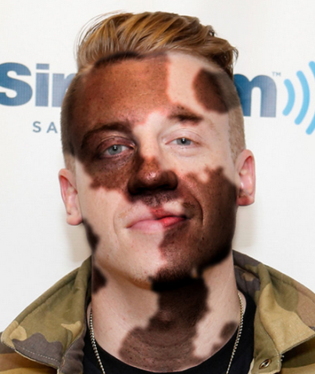  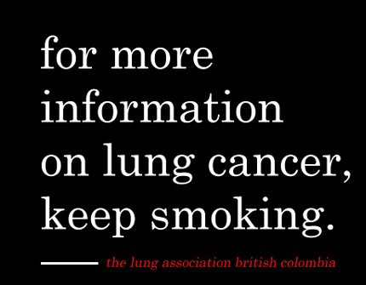  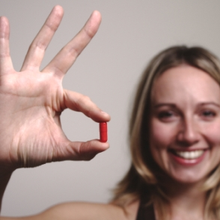    Biorepository  Volunteer to donate a  small amount of blood  that will be stored in our  Biorepository and used  by UMass researchers.  (Docket # H-12647)  For more information,  stop by the Conquering  Diseases office. We are  open 8:00 AM – 4:00 PM  Clinical Research Volunteer Database  Participate in the Clinical Research Volunteer Database. The database is used for UMass researchers who are conducting IRB approved studies.  (Docket # H-12562) | October 2015  Studies of interest  Mindfulness Heart Study (Docket # H-00000803)  We are studying the effects of a stress reduction program on physiologic parameters in subjects, with impaired heart function from a heart attack, who have an implantable defibrillator. For more information, please contact Joshua Greenberg, MD at 508-407-7930.  Patient as Teacher: Are you living with advanced (Stage 3 or 4) cancer?  (Docket # H-00006844)  Would you be interested in sharing your experiences through an interview to teach others?  If so, please consider being part of a new research study focused on the effect of the medical interview on patients with advanced (Stage 3 or 4) cancer. We hope to understand the effect of narrative interviewing techniques on patient dignity and quality of life. If you are interested, please contact Alex at alex.doering@umassmemorial.org  UMass Vitiligo Study Seeking Volunteers (Docket # 14848)  We are looking for people with and without the autoimmune skin disease called Vitiligo. We will collect a small sample of skin and in some cases a blood sample. We want to better understand how autoimmune diseases occur in the skin, including how immune cells choose to initiate disease as well as what causes them to enter the skin. For more information, please contact Mehdi Rashighi, MD or Mehdi.Rashighi@umassmed.edu  Smoking Study (Docket # H-00007800)  The goal of this study is to determine whether use of a web based decision support system helps patients with schizophrenia stop smoking cigarettes. Compensation will be provided. If you are interested and would like more information, please call 508- 856-MIND (6463) or email MIND@umassmed.edu  A Randomized Double-Blind, Placebo-controlled, sequential Parallel Comparison design (SPCD) study of Intravenous Sodium Nitroprusside in Adults with Symptomaic Schizophrenia (Docket # H-00007610)  The goal of this 6-week research study is to assess the effectiveness of Sodium Nitroprusside, an FDA approved drug for management of hypertension, can improve symptoms of schizophrenia. We seek men and women ages 18-60 with a diagnosis of schizophrenia. Participants will be compensated for their time and travel, and all information will be kept private. For more information about the study, please call 508-856-MIND (6463) or email MIND@umassmed.edu  Exenatide Weekly Injection as an Adjunctive Treatment in Patients with Schizophrenia  (Docket # H-00004119)  This study seeks to see if Exenatide, an investigational drug when used in people with schizophrenia, can improve memory and thinking in people with schizophrenia. Participation in the study will last 24 weeks. You will be compensated for your time. For more information about the study, please call us at 508-856-MIND (6463) or email MIND@umassmed.edu.

