**Young Adult Advisory Council Starting  
Up In XXXX!**

**Calling All YOUng Adults!**



**Are you a young adult between the ages of 16-24 with lived experience of a mental health condition?**

**Would you like to have YOUR voice heard and help improve work and school related services created for you and your peers?**

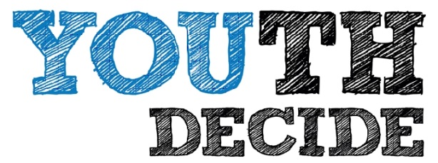

**Council Details:**

* Meetings will take place monthly in New Castle, Kenton & Sussex County
* To sign up and receive more information about our kickoff meeting, contact Your Contact Person by e-mail YourEmail@YourDomain or (XXX)-XXX-XXXX

This Council is sponsored by: Add Sponsoring Agency if Applicable

**Why is this council for YOU?!**

* Meetings are 100% Young Adult Led!
* Chance to shape services across Your Area for youth in recovery
* YOUR voice is heard and YOU lead the conversation
* Great place to meet other

youth in recovery

* Fun social activities
* FREE FOOD!

**…then you should join our**

**Young Adult Advisory Council!**