Ordering a Desktop/Laptop computer in BuyWays

Ordering a computer using the Whalley punch-out catalog
Ordering a computer using the Apple punch-out catalog
Ordering a computer that is not available in the punch-out catalogs

Ordering a computer using the Whalley punch-out catalog

- From the Shopping cart icon on the left navigation bar, follow the path ‘My Carts and Orders’, ‘View Draft Shopping Carts
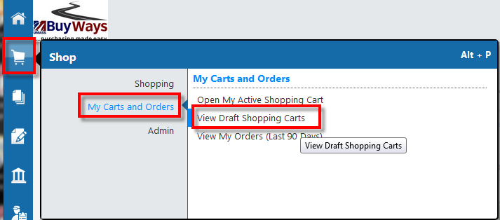

- Click on ‘Create Cart’ in the upper left corner of the screen

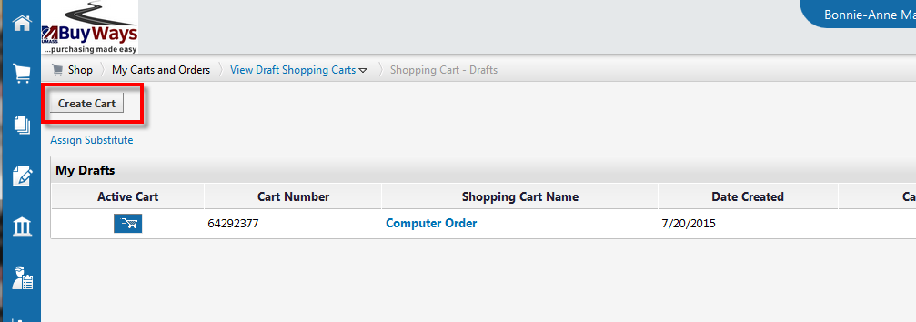

- Name your cart (recommended), the click on the link ‘Click here to start shopping’
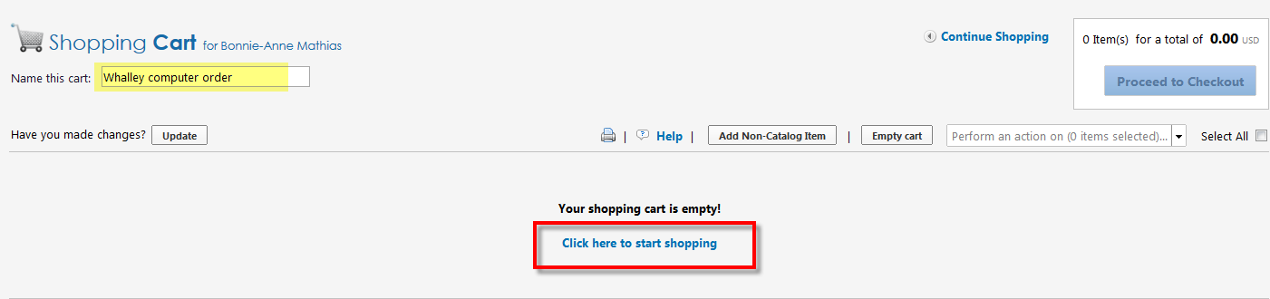

- From the Showcased Vendors, select the WCA icon to punch out to the Whalley on-line catalog.

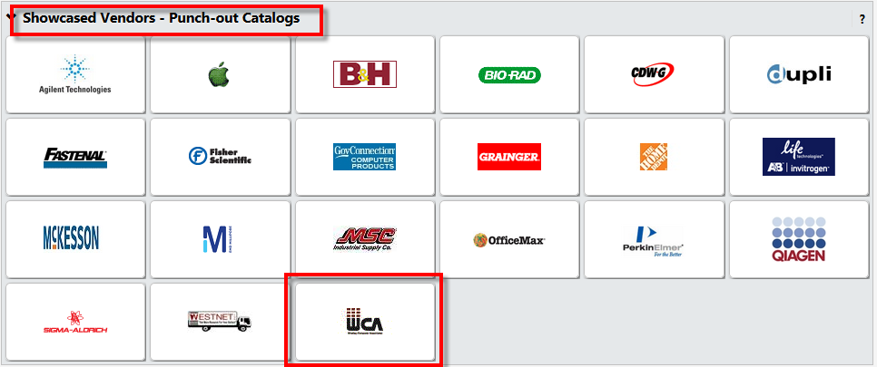

- Click on the computer model you wish to order

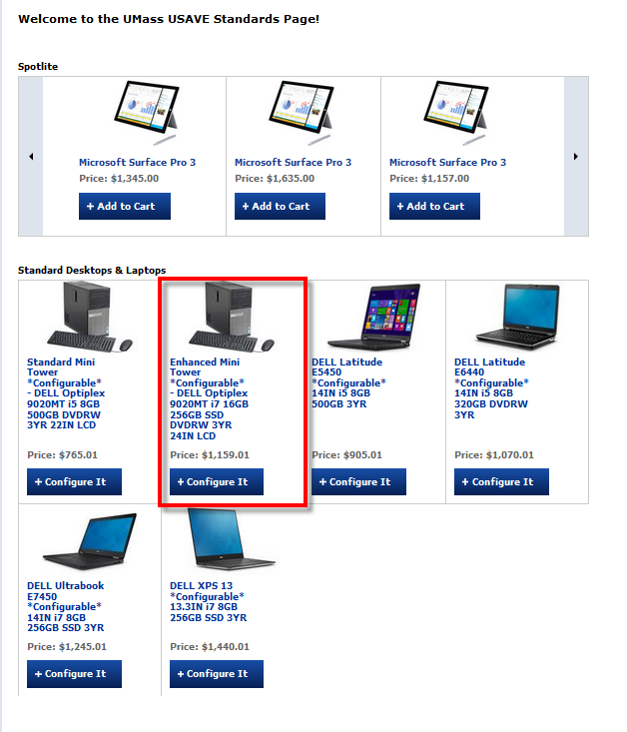

- Review the options for the computer and adjust the configuration based on your needs. Eg: If you don’t need a monitor, choose ‘No Monitor’ for an adjustment in price of -$150.

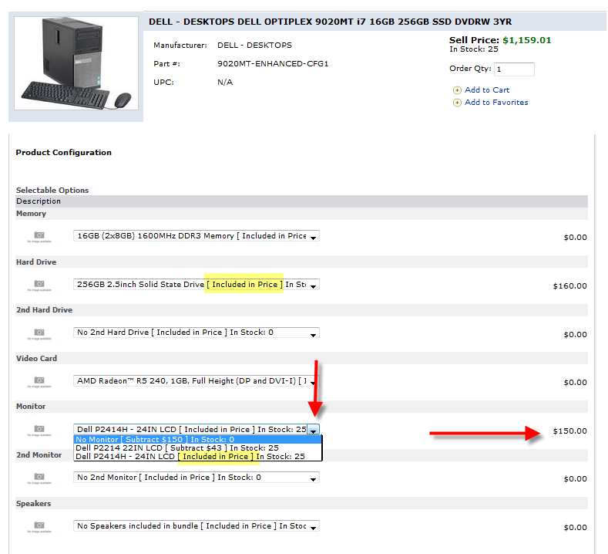

- When you have completed your configuration, the Sell Price for your computer will be updated with the total price. Type in the quantity you wish to order, then click ‘Add to Cart’

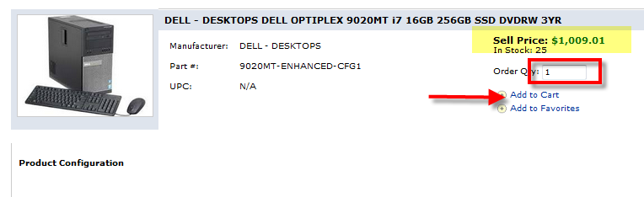

- Your configured computer will be added to the cart. Note the ‘No Monitor’ option is shown based on your configuration. Select ‘Checkout’ to return your cart to BuyWays

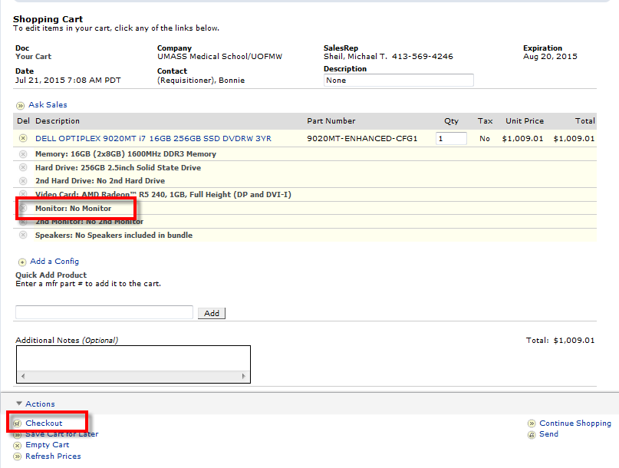

- Your items will be brought into BuyWays. Note that some items may appear with a one (1) cent cost. This is because BuyWays and Peoplesoft can’t process zero dollar or negative amounts. The vendor will include the items with a cost of one (1) cent so that the item can be processed.
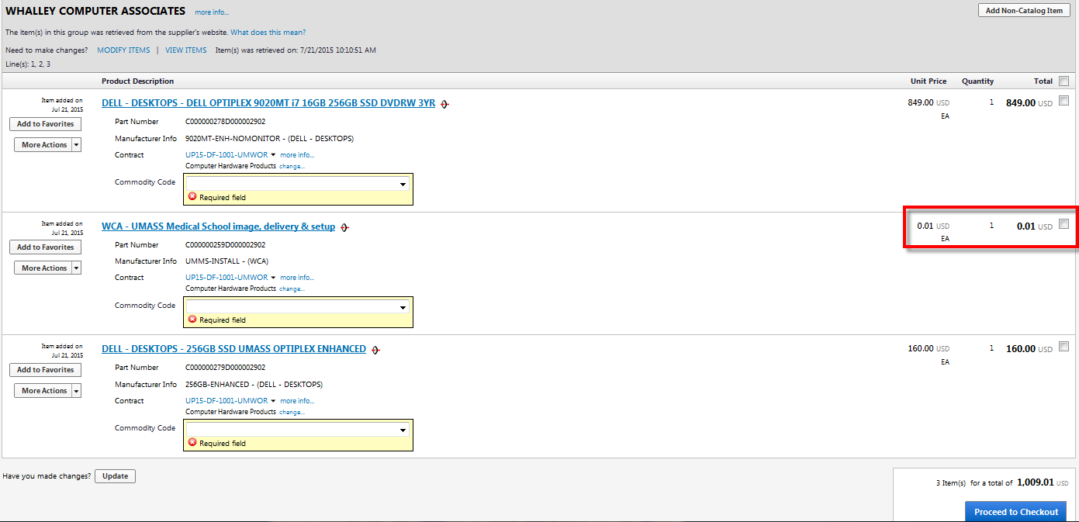

- Using the ‘Select All’ checkbox on the right side, then select ‘Change Commodity Code’

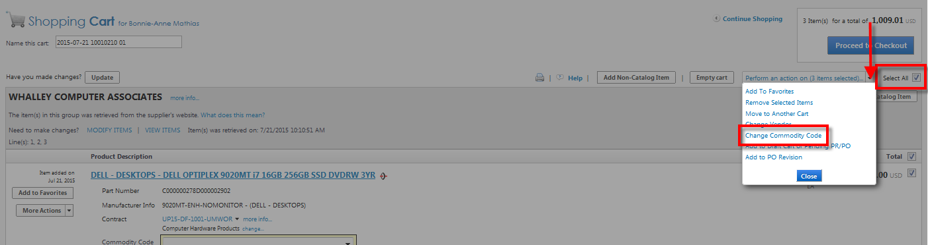

- Using the drop down box, select ‘Computers – Desktop/laptop – (UMMS Only) from the list, then ‘Save’

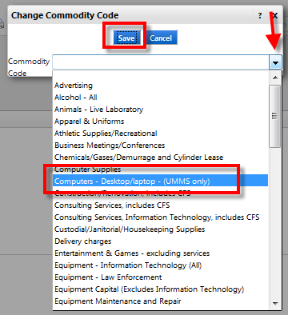

- Click ‘Proceed to Checkout’

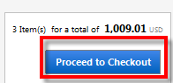

- Confirm your requisition information is correct. First, validate the shipping information. The shipping information should be where the computer will be located in the University so that the Asset Management and Information Technology departments can record and service the computer. Click ‘Edit’ to modify the information if needed.

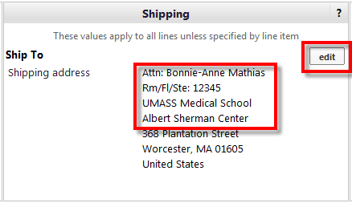

- Add your accounting information, then ‘Save’. The account code for computers under $5000 should be 741980-WA, $5000 and greater should be 763100-WA

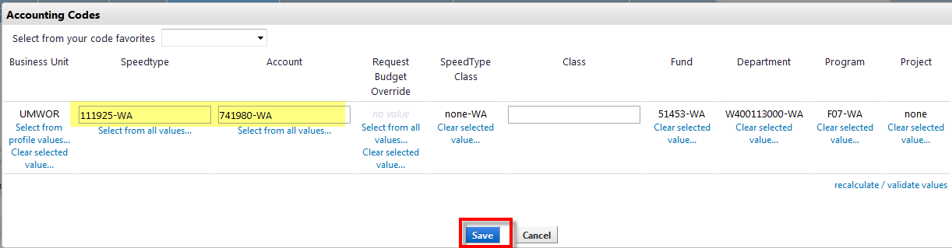

- Go to the ‘Final Review’ tab and verify the information is correct, then assign or submit your cart

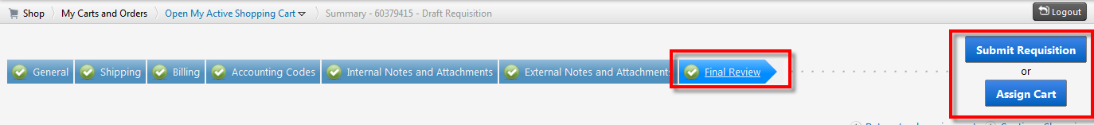

Ordering a Desktop/Laptop from the Apple Punch-out Catalog
  - In BuyWays, go to Carts, Draft Carts and click ‘Create Cart’

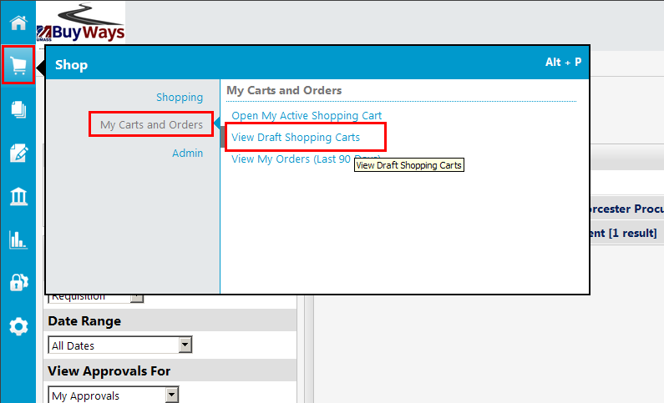

  - Type in the name for your cart (recommended), then click ‘update’. Next Click on ‘Click here to start shopping’
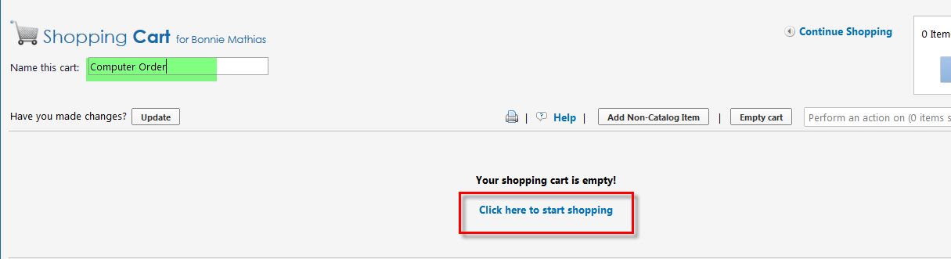

  - Choose the Apple Catalog from the Showcased Vendors
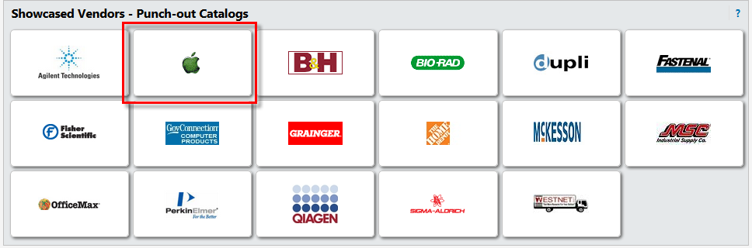

  - A new browser window will open and bring you to the Apple Store
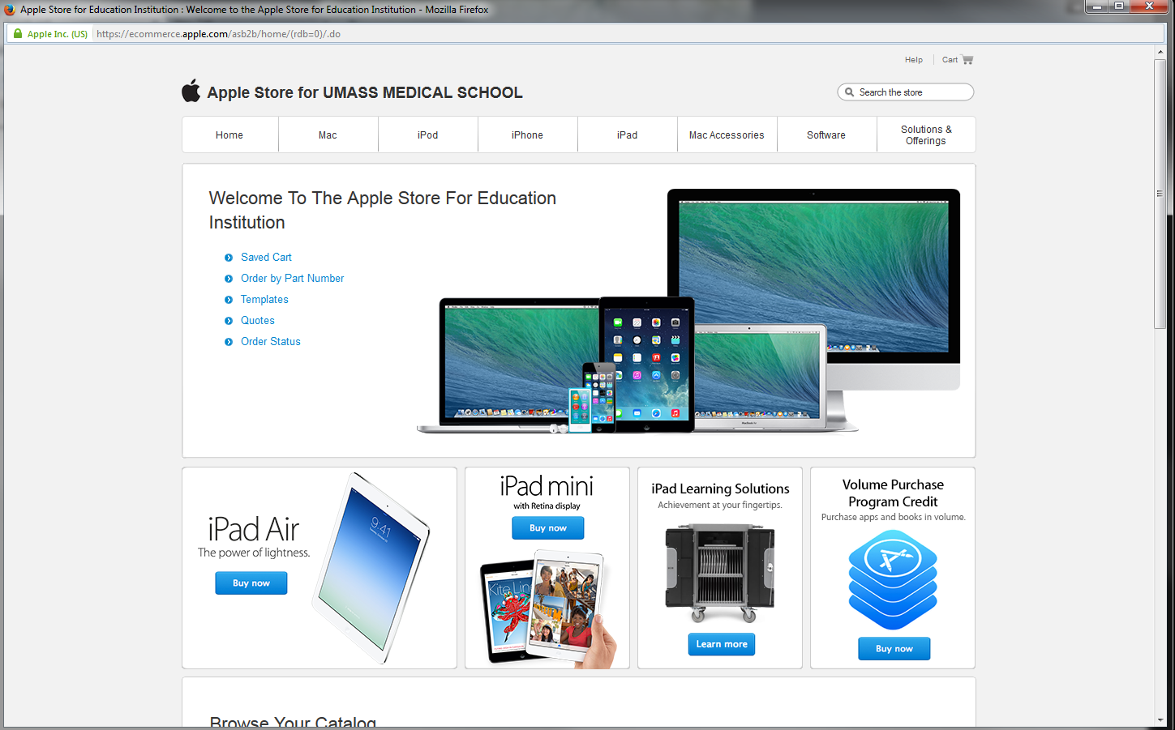
  - You can use the search box or select your items using the drop down menus. Choose your base computer by adding the Quantity needed, the click ‘Add to Cart’
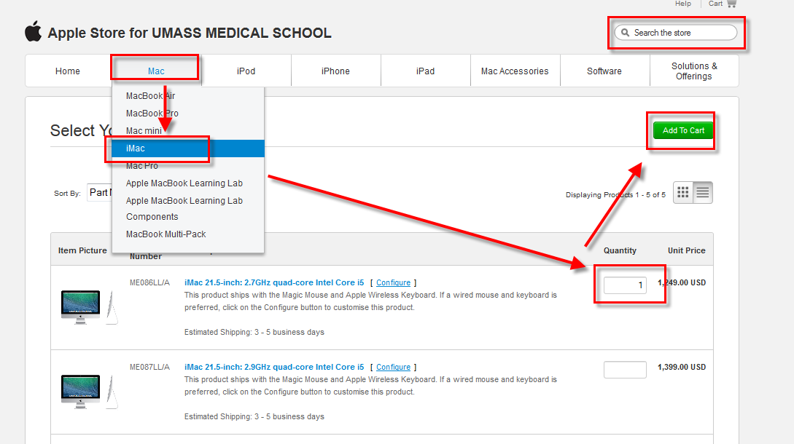
  - The next screen will show you available upgrades or options for selection. To select AppleCare protection, click the checkbox and then ‘Update’
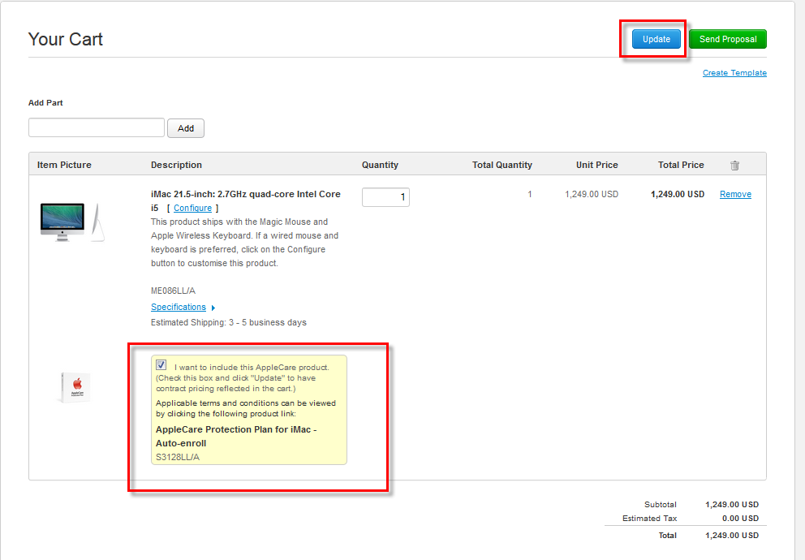
  - Your cart will be updated. Once all needed upgrades and options have been selected, click ‘Send Proposal’
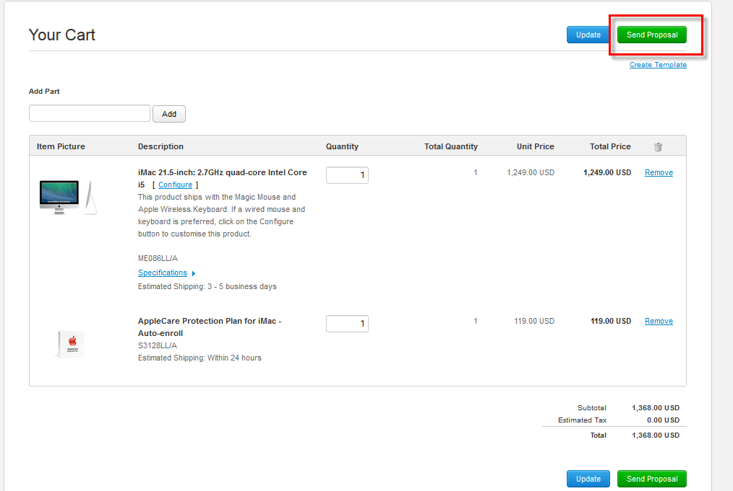
  - Confirm your order is correct, the click ‘Submit’
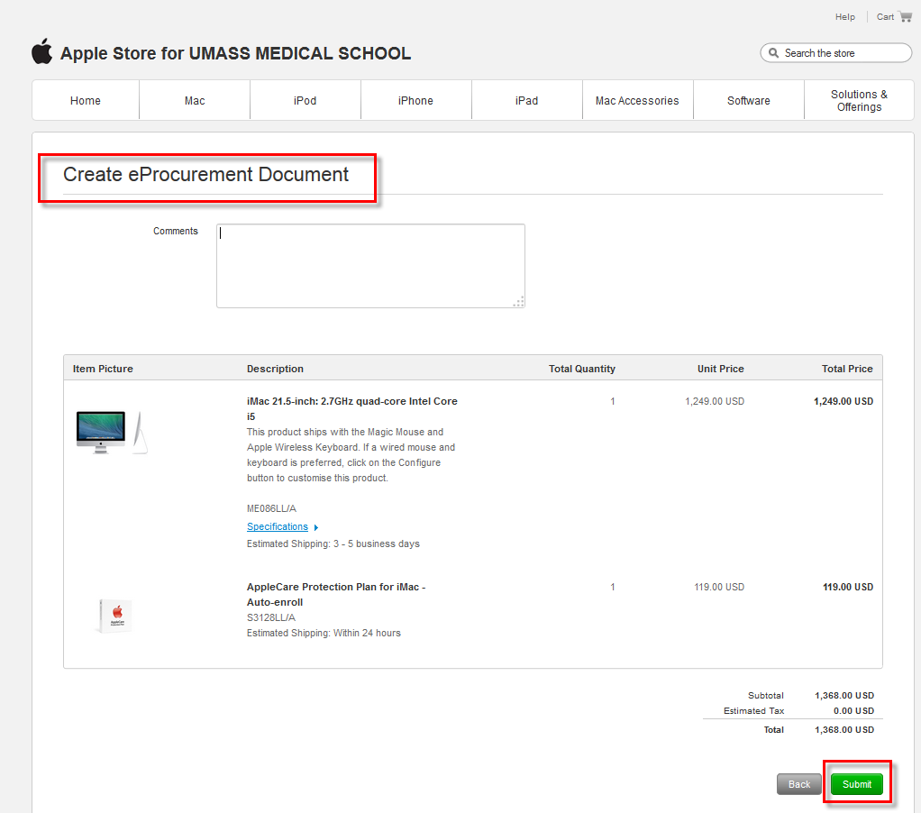
  - A confirmation screen with your proposal number is created. Click ‘Continue’ to bring the proposal information back to BuyWays to complete your requisition.
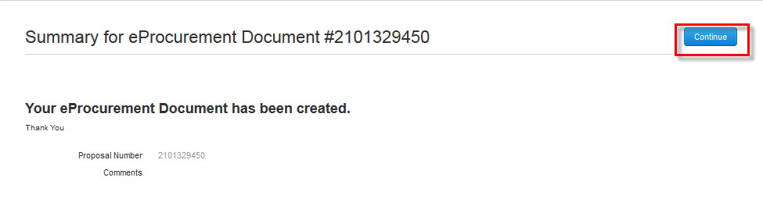

  - Using the drop down boxes on your items, choose “Computers – Desktop/Laptop – (UMMS Only) for the commodity code on each line. Then click ‘Proceed to Checkout’
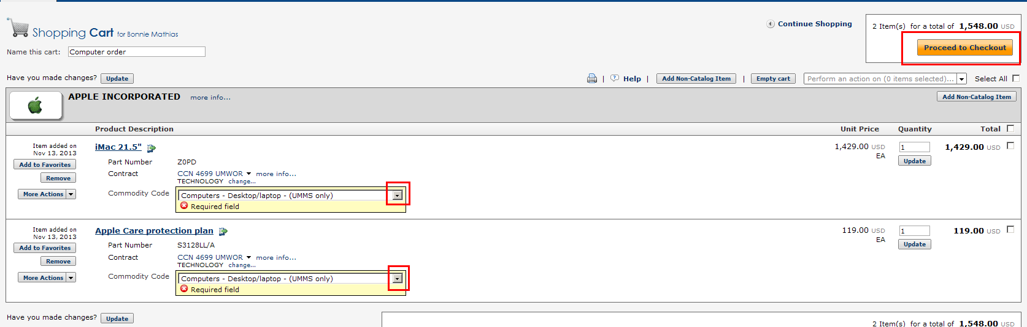

  - Validate the shipping address is correct. Please be sure this information is correct as it is used by the vendor to supply your equipment AND by the Asset Management department to tag and inventory the computer.
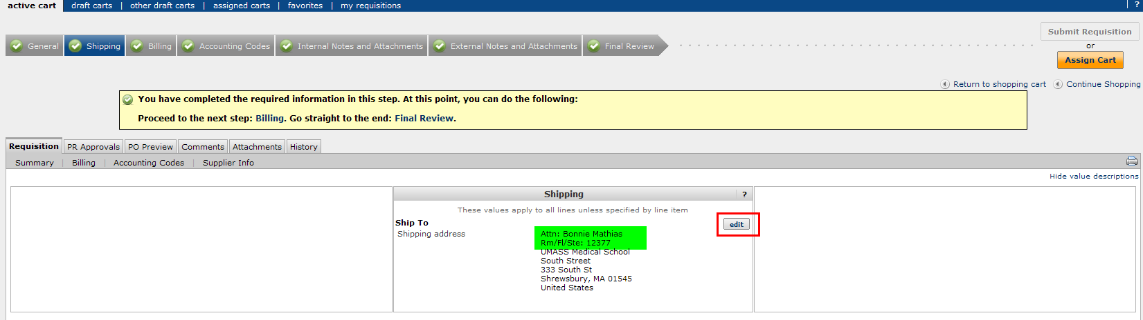

  - On the Account Codes tab, enter the Speed Type number and the Account Code of 741980-WA, then save.

  - Once your requisition information is complete, click on the ‘Final Review’ tab and Submit Requisition (Requisitioners) or Assign Cart (Shoppers) to move your requisition to workflow
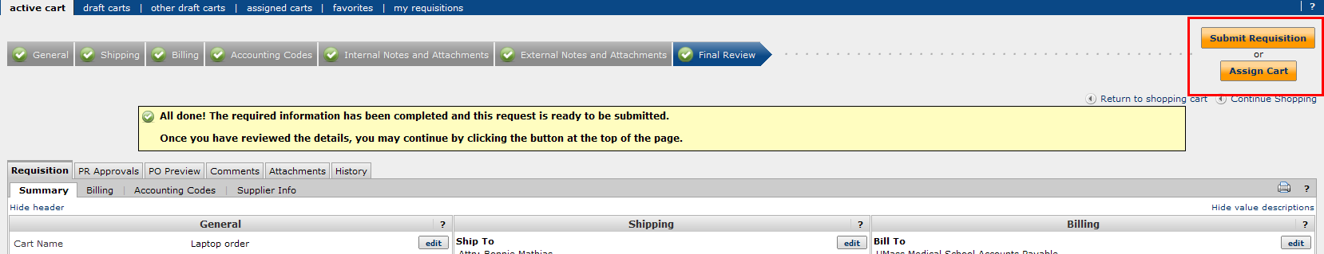

Ordering a computer using the non-catalog item form
  - In BuyWays, go to Carts, Draft Carts and click ‘Create Cart’

  - Using the Non-Catalog item pop up form, enter the vendor name, product description, catalog (item) number, quantity and quoted price. Select either Save & close (if it a single item order) or Save and add another if you have additional items. Note: You must include a separate line on your requisition for each line with an associated cost. Do not enter lines for zero charge items – those should be included in the ‘Notes to all suppliers’ section.
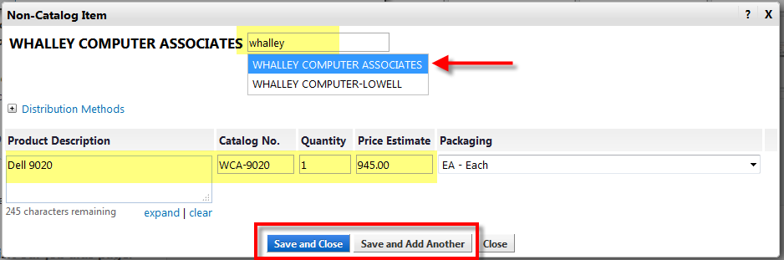
  - Your item will be added to your shopping cart. Click on the shopping cart icon in the upper right corner of the page and click on ‘View my Cart’ to complete your cart information

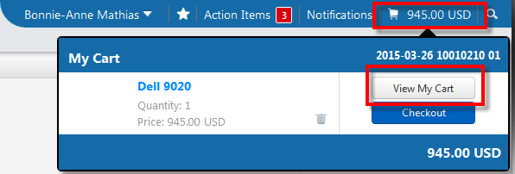

  - Using either the drop down box under the item description, or using ‘Select All’ and ‘Change Commodity Code’ from the available options drop down box, select the appropriate commodity code for your items (under $5000 – Computers-Desktop/Laptop, over $5000 – Equipment – Information Technology (All))
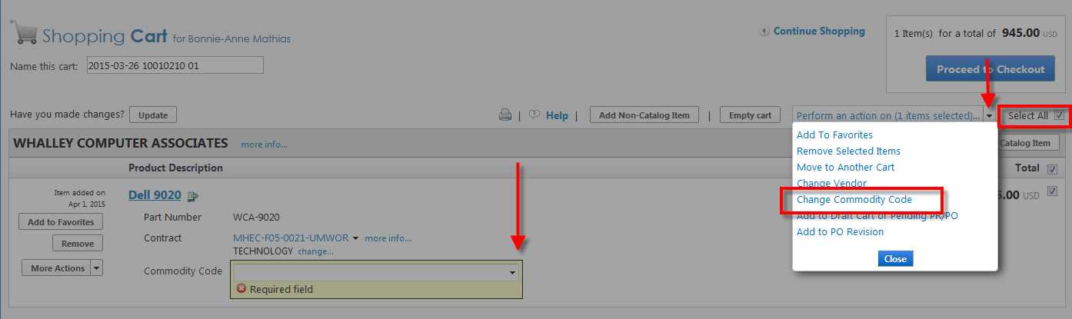

  - Click on Proceed to checkout on the upper right side of the page
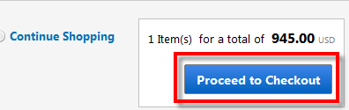
Confirm your requisition information is correct. First, validate the shipping information. The shipping information should be where the computer will be located in the University so that the Asset Management and Information Technology departments can record and service the computer. Click ‘Edit’ to modify the information if needed.

Add your accounting information. The account code for computers under $5000 should be 741980-WA, $5000 and greater should be 763100-WA

  - Add the vendor quote number and any no charge item information to the ‘Note to all Suppliers’ field on the External Notes and Attachments tab by clicking ‘Edit’
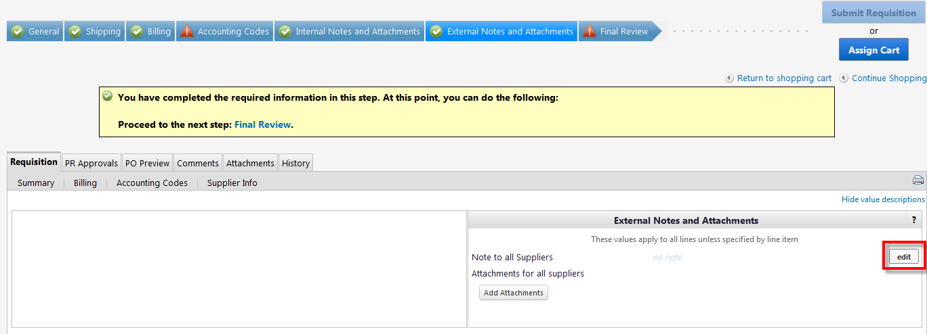

  - Click ‘Save’ when your information has been added
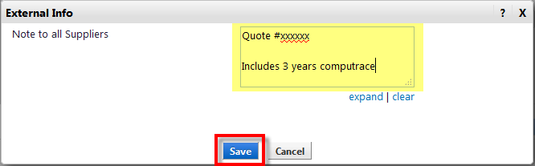

  - Click ‘Add Attachments’ to attach a copy of your vendor quote
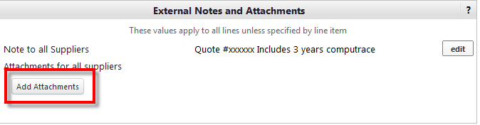
  - Click ‘Select files’, to find the quote on your desktop, then ‘Save Changes’

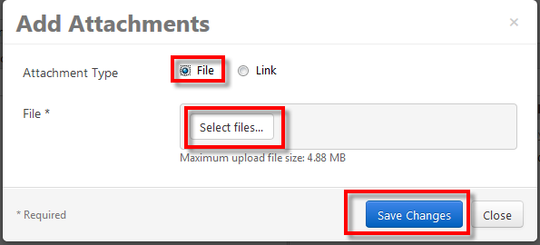

Go to the ‘Final Review’ tab and verify the information is correct, then assign or submit your cart

