Host In Meeting Controls

In Meeting Controls | Description
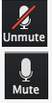 | Mute/Unmute: This allows you to mute and unmute your microphone
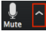 | Audio Controls (via the ^ arrow next to mute/unmute): The audio controls allow you to change the microphone and speaker that Zoom is currently using on your computer, leave computer audio, and access the full audio options in the Zoom settings.
 | Start/Stop Video: This allows you to start and stop your own video.
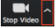 | Video Controls (via the ^ arrow next to Start/Stop Video): If you have multiple cameras on your computer, you can select which Zoom is using, access the full video controls, and select a Virtual Background
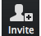 | Invite: During a meeting, you can invite people to join the conference.
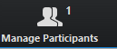 | Participants: This opens the Participants window
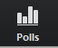 | Polling: This allows you to create, edit, and launch your polls. The options to create or launch polls will open the Zoom web portal in your default browser.
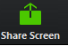 | Share Screen: Click on this to start a screen share. You will be able to select the desktop or application you want to share.
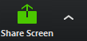 | Screen Share Controls (via the ^ next to Share Screen): Select who can share in your webinar and if you want only the host or any panelist to be able to start a new share when someone is sharing.
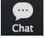 | Chat: Access the chat window to chat with the panelists or all attendees.
 | End Meeting: This will end the meeting for all participants. If you want to have the webinar continue, you should give another participant host control before leaving the webinar.

